10/2/2019

James Dwyer, Michael Fielder, David Gravett

Lockheed martin (Rebecca broadway, tanner lindbloom)

EVERGLADES

Game Development for Reinforcement Learning

Table of Contents

**Project Description2**

Motivations2

Goals and Objectives3

Function3

Criteria and Constraints3

Broader Impacts4

**Specifications** **and** **Requirements5**

**Ideas7**

**Block Diagrams10**

**Technical Specifications12**

Code Base Characterization13

Code Structure Overview13

Newly Added Features22

Future Improvement Ideas25

Randomized Game Board28

Implementation Ideas28

Chosen Method Overview30

Process Diagram36

Future Improvement Ideas41

Wind Effects with Seeded Stochasticity43

Implementation Ideas43

Chosen Method Overview45

Process Diagram51

Future Improvement Ideas56

Reinforcement Learning Support58

AI Agent Integration Process58

Future Improvement Ideas63

Drone Destruction Animation65

Animation Design Process65

Future Improvement Ideas71

New Drone Unit73

Drone Implementation Ideas73

Chosen Method Overview76

Unit Structure Diagram83

Future Improvement Ideas86

**Budget88**

**Project Milestones89**

**Project Summary90**

**Conclusion91**

**References92**

Project Description

# Motivations

## James

As someone who enjoys gaming in his spare time, the thought of game development has always been appealing. I saw this project as an opportunity to expand my understanding of the Unreal Engine and to develop a game that exceeds the expectations of the sponsor. Given that we are expanding upon an existing codebase, the chance to read, understand, and document the existing program mirrors tasks that can be expected of developers throughout their career. Working on a project that uses Docker containers and reinforcement learning also introduce me to new aspects of development that I hope will improve my capabilities as a software engineer.

David

My interest in programming first began in Middle School when I used to play a game called Roblox. This game allowed you to create your own games using 3D map design and LUA based programming. Playing this game and creating my own games began my overall interest in pursuing programming as a career. Once I entered High School, I took a Game Development class which helped me learn the basics of game design and implementation. After taking this class, I took many other programming related classes over the next 3 years that allowed me to create Windows and Android based Java games. Ever since these earlier times in my academic career I have been interested in the prospects of a career in Game Development and have now been given a chance to practice in this area of computer science.

Michael

I’ve been playing video games since I was a toddler and have been playing games ever since, so it was a no brainer to choose a project that focuses on game development. I also understand the general process of creating a game from a Unity game development course I took in my Senior year of high school. My other motivation for completing this project is learning Unreal Engine 4, which is an important software to learn. The final motivation that I have for completing this project is to learn how to create software that aids in the machine learning process. Machine learning is one of the most sought-after skills in the programming field, and any project that helps you improve those skills is beneficial. Overall, I feel that I am very motivated to produce my best work on this project.

# 

Project Description

# Goals and Objectives

The overall goal of our project is to further develop the EVERGLADES AI training application by characterizing the code, adding procedurally generated game boards, and to finally add stochastically seeded wind. In order to achieve a truly procedurally generated game board, the application should be able to create game boards with varying amounts of nodes, connections between those nodes, and structures. As for the wind, it should be able to also produces varying orientations.

Function

The EVERGLADES project is an artificial intelligence game that facilitates AI training and research and through a turn-based game board that controls multiple drone swarms. The purpose of the game portion is to create a playground for training both teams while also providing a graphical representation of the game space through post-processing in Unreal Engine. The actual server for the game is contained in the application Docker, and this is where the AI’s are trained.

# Criteria and Constraints

The constraints of our project include incorporating the current Docker environment for the game server as it is the entity that is providing the telemetry output data that is used for post-processing. As for the post-processing itself, that must be developed using the architecture that was already created using Unreal Engine.

# 

# Broader Impacts

Due to the nature of the game, the most significant global impact from the results of this project is its influence on national security. Military drones are an integral part of contemporary warfare, and they become more important as technology becomes more advanced. Our project directly satisfies the goals of improving the high-level decision-making of drones against a sophisticated and constantly changing enemy. National security involves conflict that is spontaneous, and it requires technology that can react quickly and efficiently. Therefore, it is safe to say that our project could have an impact on national security by possibly improving the way that drones assess impending threats.

A more local impact that our technology could have is within Lockheed Martin itself. The data the EVERGLADES Project collects can be used to advance drone technology by serving as a data set that can drive further developments in the right direction. It could also spark new machine learning development if there are any interesting unexpected discoveries that come from our project. Indeed, our project could provide Lockheed Martin invaluable high-level information that they could use for analysis. The code on its own is also highly scalable and could be expanded on to include elements such as a more sophisticated map and a fully 3-D movement system in order to more closely simulate real-life drone combat.

# Specifications and Requirements

|  |  |
| --- | --- |
| ID | Description |
| Characterize Codebase | |
| 101 | Each class will have a short description of what it is and its purpose |
| 102 | Each major function will have a description of its purpose |
| 103 | Each major function’s parameters will have a description and include their constraints |
| 104 | Each major function will have a description of its output and the output’s constraints |
| 105 | Diagrams of class interactions will be created |
| 106 | There will be an overview of how matches are run by the user |
| 107 | There will be an overview of how file paths must be set |
| Procedural Generation of Game Board | |
| 201 | Game board will not exceed 50 nodes in size, excluding the two home bases |
| 202 | Game board will be randomly generated |
| 203 | Procedural generation of game board will be seeded |
| 204 | Game board will be valid, meaning there is at least one travelable, valid path from one home base to the other |
| 205 | Game will present user with option to choose a game board that is either “fair” or “unfair” |
| 206 | A “fair” game board will be symmetrical, ensuring that the same number of nodes will be passed through when traveling similar paths from either home base and ending at the opposite home base |
| 207 | A breadth first search will be used to generate the valid, random game board |
| 208 | The user will choose a weight to determine the density of node clusters |
| 209 | An “unfair” game board will favor one of the opposing teams by providing the advantage of having more neutral nodes near their home base |
| Wind Effects | |
| 301 | Wind will be stochastic |
| 302 | Stochasticity will be seeded |
| 303 | Wind will affect swarms’ ability to travel |
| 304 | Wind will visibly affect the scene in the game graphics |
| 305 | Wind will utilize vectors, specifically their x and y components to calculate the effect on swarm movement |

|  |  |
| --- | --- |
| RL Algorithm Training | |
| 401 | RL algorithm is affected by playing the game |
| 402 | RL algorithm can be trained by replaying the game |
| Drone Death Animation | |
| 501 | Drones will explode when destroyed |
| 502 | Explosion will be proportional to drone size |
| 503 | Explosion animation will replace the drone asset |
| New Unit Class | |
| 601 | New unit class will have an attached sensor |
| 602 | Sensor will be infrared |
| 603 | Unit sensor will appropriately affect gameplay |
| 604 | Sensor properties can be configured by input file |
| 605 | Unit will be visually unique compared to other units |
| 606 | Game objects will have a thermal property representing the wavelength of the infrared radiation emitted |
| 607 | Infrared wavelength will be calculated based on a realistic estimation of the object’s temperature |
| 608 | Drones will leave infrared traces in their wake |
| 609 | An infrared visual effect will be shown when viewing the game from the perspective of the new unit |

Block Diagrams

* Overall Game Process, all components currently exist, and we will be improving the Game Server and Unreal Engine Graphics Post Processing. 

Block Diagrams

* Project Goals

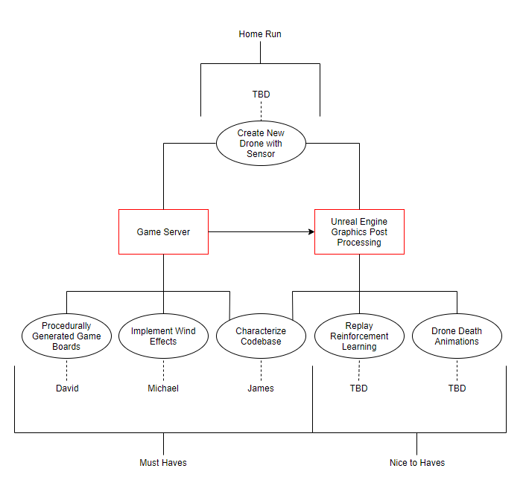

Budget

This project does not require any budget. All software and hosting services are either free to use or have already been purchased by the Sponsor.

* Software Required:
  + Unreal Engine 4 (Free)
  + Visual Studio Community 2017/2019 (Free)
  + 3D Modeling Software such as Autodesk Maya (Not currently sure if required, software such as Autodesk Maya are free for Students to use)
  + Docker Containers (Free)





Project Milestones

|  |  |  |  |
| --- | --- | --- | --- |
| No. | Task | Due | Status |
| Senior Design I (research, documentation, design) | | | |
| 1 | Project Kickoff | 9/24/2019 | Complete |
| 2 | Learn UE4 and Docker | Ongoing | In Progress |
| 3 | Initial Design Document | 10/2/2019 | Complete |
| 4 | TA Meeting I | 10/5/2019 | Complete |
| 5 | Research Ideas for Implementation | 10/13/2019 | Complete |
| 6 | Prof. Heinrich Meeting | 10/16/2019 | Complete |
| 7 | Broad Understanding of Existing Codebase | 10/23/2019 | Not Started |
| 8 | Lockheed Meeting | 10/30/2019 | Not Started |
| 9 | Edit Document w/ Sponsor Feedback | 11/3/2019 | Not Started |
| 10 | TA Meeting II | 11/11/2019 | Not Started |
| 11 | Edit Document w/ TA Suggestions | 11/17/2019 | Not Started |
| 12 | Design Document Editing | 12/1/2019 | Not Started |
| 13 | Final Design Document | 12/5/2019 | Not Started |
| Senior Design II (implementation) | | | |
| 1 | Must-haves Implemented | 1/20/2020 | Not Started |
| 2 | Nice-to-haves Implemented | 2/3/2020 | Not Started |
| 3 | Homerun Implemented | 2/17/2020 | Not Started |
| 4 | Further Testing and Debugging | 3/2/2020 | Not Started |
| 5 | Final Document Edit | 3/16/2020 | Not Started |
| 6 | Presentation Prepared | 3/23/2020 | Not Started |
| 7 | Project Complete | 4/1/2020 | Not Started |
| 8 | Project Presentation | TBD | Not Started |

Technical Specifications

Code Base Characterization

Purpose

Characterizing the code base of the previous iteration of Everglades: Game Development will give us a thorough understanding of how the existing classes and procedures affect the overall flow of the game. Understanding the current structure of the game is critical to effectively integrate our improvements and additions.

This also serves as a valuable learning experience. Most developers work with completed code that they alter or expand, rather than coding from scratch. They may even be tasked with characterizing a code base a few times throughout their career.

Structure

As shown in the overall game process block diagram (see figure X), the game’s environment exists on the server and the menu and post-processed graphics are on the client. Users can choose to view an existing telemetry file or to play a match between two AI agents on the server (see figure 1).



*Figure 1: Everglades menu showing choice of telemetry or server*

The code for the game logic is composed of python files which are separated into different folders depending on the function as shown in figure 2.



Figure 2: Files and folders contained in Everglades

The *agents* folder contains python files that dictate the logic of an AI agent. There are three default programs within, but users can create and save their own to the folder. Then, their script can be selected and used in an Everglades match.

The *config* folder has four JSON files used to configure the game during initialization. They provide data for the initialization of the map, game, players, and units. The values can be altered if a user wishes to customize their Everglades match, but some changes may cause errors.

The game logic is within the *everglades-server* folder. It has two Python files: one containing server logic, the other with initializations for various classes in the game.

As Everglades matches run, they output data that is stored in the *game_telemetry* folder. This data can be used to provide insight for different areas of the match and for use by Unreal Engine to provide post-processed visualizations.

The *gym-everglades* folder contains the OpenAI Gym for Everglades. It is a Python file that initializes the game with the AI agents and sets up the observation and action spaces.

The *.gitignore* file is used by version control to ignore changes to certain files. While any file can be included, it currently ignores compiled files and telemetry output.

*README* is a markdown file containing information related to the installation of Everglades. It also contains descriptions of the folders’ contents.

*SeniorDesignDocument* is this file.

Finally, *test_battle* is a Python script that runs two agents against each other in an Everglades match.

Class Diagram

This shows an overview of class associations regarding which class is responsible for the other. Child classes point to the parent.

The main script, *test_battle.py*,constructs the OpenAI Gym from *EvergladesEnv*, the class containing the information on the Everglades environment. *EvergladesEnv* creates an instance of *EvergladesGame*. Note that *GameSetup.json* contains configuration data for an Everglades match, but the game does not use this file, currently. *EvergladesEnv* also contains data for players, but this is information on the AI agents, not the *EvgPlayer* class.

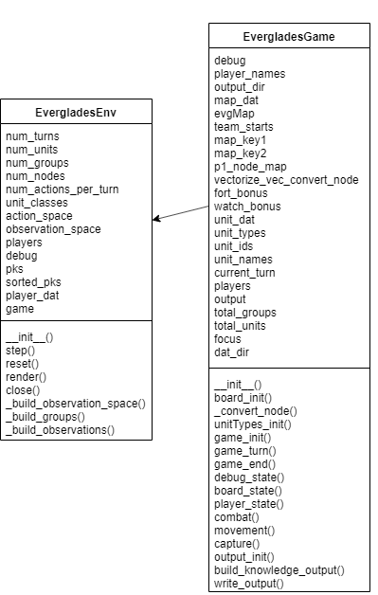

Figure 3: EvergladesEnv contains EvergladesGame

*EvergladesGame* creates instances of the *EvgMap*, *EvgPlayer*, and *EvgUnitDefinition* classes. It passes information from *DemoMap.json* to *EvgMap* to instantiate the map and *UnitDefinitions.json* to *EvgUnitDefinition* to instantiate the unit types. Note that *PlayerConfig.json* contains some data on a player’s group compositions, but this file is not currently used.

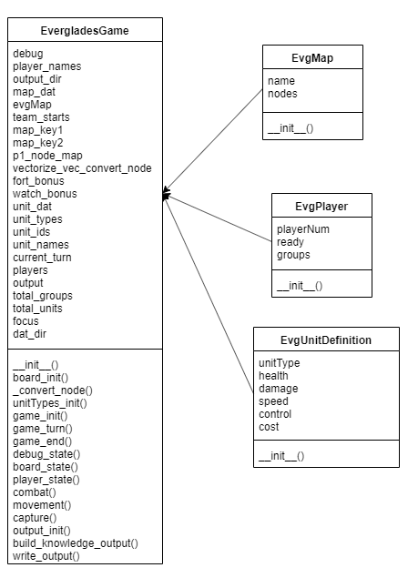

Figure 4: EvergladesGame contains EvgMap, EvgPlayer, and EvgUnitDefinition

*EvgMap*, *EvgMapNode*, and *EvgNodeConnection* are instantiated by *EvergladesGame*. However, *EvgMapNode* is contained within *EvgMap* and *EvgNodeConnection* is within *EvgMapNode*.

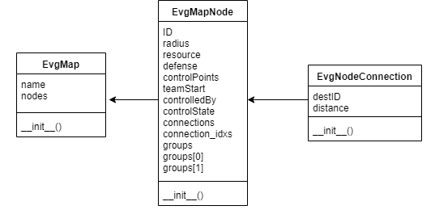

Figure 5: EvgMap contains EvgMapNode. EvgMapNode contains EvgNodeConnection

*EvgPlayer*, *EvgGroup*, and *EvgUnit* are each instantiated by *EvergladesGame*. *EvgUnit* creates an instance of *EvgUnitDefinition* for each unit in the game and initially contains null values. *EvergladesGame* then replaces these null values with the corresponding actual values contained in its own unit definition instance.

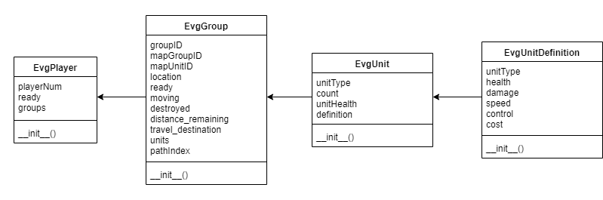

Figure 6: EvgPlayer contains instances of EvgGroup, which contains instances of EvgUnit, which contains an instance of EvgUnitDefinition

Classes

What follows is a brief description of the contents of each class including properties and functions. A more thorough description of the Everglades classes will be included in a markdown file deliverable.

Note for some properties, *int* or *float* may be listed as the type. Python is dynamically typed, so the types of these variables depends on the data that is passed to them. Some variables have default values that are integers but receive floats from the configuration file.

#### EvgMap in definitions.py

The class of the Everglades map. It only contains the map initializer.

Properties:

1. *string* **name**: The name of the map.
2. *list* **nodes**: The list of nodes within the map.

#### EvgMapNode in definitions.py

The class of the nodes that make up the everglades map. It only contains the node initializer.

Properties:

1. *int* **ID**: The identification number of the node.
2. *float* **radius**: The radius of the node.
3. *list* **resource**: A list of the resources for the node. It contains ‘OBSERVE’ for watchtower, ‘DEFENSE’ for fortress, and an empty list for a node with no resources.
4. *int* **defense**: The defense value for the node.
5. *int* **controlPoints**: The amount of points a player receives for controlling the node.
6. *int* **teamStart**: Indicates the node is a team’s home base. It is 0 for player 0, 1 for player 1, and -1 for all neutral nodes.
7. *int* **controlledBy**: Indicates which player controls the node. It uses the same integer values as teamStart.
8. *float* **controlState**: This is the percentage that the node is under control.
9. *list* **connections**: The list of tuples containing valid connections from this node and the respective distances.
10. *list* **connection_idxs**: The list of valid connections from this node.
11. dict **groups**: The key is the player number (0 or 1) and the value is a list of group IDs. (see entries 12 and 13 that follow)
12. *list* **groups[0]**: The IDs of Player 0’s groups located at this node.
13. *list* **groups[1]**: The IDs of Player 1’s groups located at this node.

#### EvgNodeConnection in definitions.py

The class of the connection between two nodes. It only contains the connection initializer.

Properties:

1. *int* **destID**: The identification number of the destination node.
2. *int* **distance**: The distance to the destination node.

#### EvgPlayer in definitions.py

The class of the Everglades player. It only contains the player initializer.

Properties:

1. *int* **playerNum**: The identification number for the player.
2. *bool* **ready**: ***I can’t find a manipulation of this field***
3. *list<EvgGroup>* **groups**: The list of groups belonging to the player.

#### EvgGroup in definitions.py

The class of a group of drones, a swarm. It contains only the group initializer.

Properties:

1. *int* **groupID**: The identification number for the group.
2. *int* **mapGroupID**: A cumulative group identification for outputting the initial number of groups on the map.
3. *int* **mapUnitID**: A cumulative unit identification for outputting the initial number of units on the map.
4. *int* **location**: The node where the group is located.
5. *bool* **ready**: This indicates if the group is ready to move.
6. *bool* **moving**: This indicates if the group is currently moving.
7. *bool* **destroyed**: This indicates if the group has been destroyed.
8. *int* **distance_remaining**: The remaining distance the group must travel to reach the destination node.
9. *int* **travel_destination**: The node to which the group is traveling.
10. *list<EvgUnit>* **units**: The list of units contained in the group.
11. *int* **pathIndex**: ***I can’t find a manipulation of this field.***

#### EvgUnitDefinition in definitions.py

The class of the Everglades drone unit definition. It defines the stats of the unit. It contains only the unit definition initializer.

Properties:

1. *string* **unitType**: The name of the type of unit.
2. *int* **health**: The initial health of this unit type.
3. *int* **damage**: The damage of this unit type.
4. *int* **speed**: The speed of this unit type.
5. *int* **control**: The control of this unit type. This affects capture speed.
6. *int* **cost**: The cost of this unit type. The current cost of all unit types is 1.

#### EvgUnit in definition.py

The class of the Everglades drone unit. Currently, a group must be all the same unit types. Thus, a group of eight units is treated as one unit with eight health values. It contains only the unit initializer.

Properties:

1. *string* **unitType**: The type of the unit for the group.
2. *int* **count**: The amount of this type of unit for the group.
3. *array<int>* **unitHealth**: An array of health values for each unit. Its length is the value of count.
4. *EvgUnitDefinition* **definition**: It contains the definition of the unit type.

#### EvergladesGame in server.py

The class of the Everglades game. It contains the game logic.

Properties:

1. *bool* **debug**: This flag allows the masking of fog of war for debugging purposes.
2. *dict* **player_names**: This contains the names of the agent modules.
3. *string* **output_dir**: The destination directory for telemetry output.
4. *Map* **map_dat**: This contains the map data read from the configuration file.
5. *EvgMap* **evgMap**: This is an instance of the Everglades map.
6. *dict* **team_starts**: Contains team’s starting nodes, pulled from map_dat, which got it from the map json file. 0 = player 1 start, 1 = player 2 start, -1 = neutral nodes.
7. *array<int>* **map_key1**: Length is the number of map nodes. Array sorted by index of evgMap node and populated by node IDs.
8. *array<int>* **map_key2**: Length is the number of map nodes. Array sorted by node ID and populated by indices of evgMap nodes.
9. *array<int>* **p1_node_map**: Array of node IDs from player 1 perspective
10. **vectorize _vec_convert_node**: Vectorized version of _convert_node function.
11. *int* **fort_bonus**: Fortress defense multiplier.
12. *int* **watch_bonus**: Watchtower vision bonus.
13. *Units* **unit_dat**: Read Unit data from .json file. Contains the types and stats of the units (health, damage, speed, etc.).
14. *list<EvgUnitDefinition>* **unit_types**: List of each type of unit with respective stats as retrieved from the .json file.
15. *dict* **unit_ids**: Key is int uid, the order that the types were processed, starting at 0. Value is unit_type.
16. *dict* **unit_names**: Key is unit_type. Value is int uid, the order that the types were processed, starting at 0.
17. *int* **current_turn**: The current turn in the game.
18. *dict* **players**: The key is the player key (0 or 1). The value is an instance of EvgPlayer.
19. *dict* **output**: Key is name of telemetry file. Value is the data for that telemetry file. Also contains a header.
20. *int* **total_groups**: Total amount of groups in the game
21. *int* **total_units**: Total amount of units in the game
22. *int* **focus**: Group number on which to focus.
23. *string* **dat_dir**: Folder name containing that game instance’s telemetry files

Methods:

1. **__init__ ()**: Initializes instance of EvergladesGame class
2. **board_init()**: Initializes the game board
3. **_convert_node()**: Returns corresponding node from p1_node_map
4. **unitTypes_init()**: Initializes the types of units
5. **game_init()**: Initializes the game by assigning player numbers and calling functions to initialize players and units.
6. **game_turn()**: Validates player turns and calls functions defining actions that make up a turn including movement, combat, capture, and building knowledge output.
7. **game_end()**: Calculates score based on controlled nodes and checks for game ending conditions. Outputs game data to telemetry files.
8. **debug_state()**: Outputs turn-by-turn debug information to console.
9. **board_state()**: Returns the state of the game board.
10. **player_state()**: Returns the state of the player’s groups.
11. **combat()**: Controls unit combat which occurs before movement. Damage is calculated, destroyed units and groups are removed, and output is sent to telemetry file.
12. **movement()**: Moves units to nodes. Outputs movement to telemetry file.
13. **capture()**: Checks for capture conditions and then captures nodes. Outputs node control data to telemetry file.
14. **output_init()**: Initializes the telemetry files.
15. **build_knowledge_output()**: Builds player knowledge of groups and nodes. Outputs data to telemetry file.
16. **write_output()**: Writes the csv telemetry files.

#### EvergladesEnv in everglades_env.py

The class for the Everglades environment. It contains the OpenAI Gym for the project.

Properties:

1. *int* **num_turns**: The number of turns in a game.
2. *int* **num_units**: The total number of units per player.
3. *int* **num_groups**: The number of groups per player.
4. *int* **num_nodes**: The number of nodes in the map.
5. *int* **num_actions_per_turn**: The number of actions a player may take per turn.
6. *list* **unit_classes**: The types of units in the game.
7. *Tuple* **action_space**: This defines the range of actions an agent may take.
8. *Box* **observation_space**: This defines the boundaries of observation.
9. *dict* **players**: This contains an instance of the agent class for each player.
10. *bool* **debug**: This flag allows the masking of fog of war for debugging purposes.
11. *list<dict_keys>* **pks**: The list of keys for the player dictionary.
12. *list<dict_keys>* **sorted_pks**: The sorted list of keys for the player dictionary.
13. *dict* **player_dat**: This contains the unit groups for each player.
14. *EvergladesGame* **game**: This is an instance of the Everglades game.

Methods:

1. **__init__()**: This initializes the instance of the EvergladesEnv class.
2. **step()**: This returns an observation, reward, done, and info for each timestep. It is returned from the environment every time an agent makes an action.
3. **reset()**: Resets the game.
4. **render()**: ***This function is empty.***
5. **close()**: ***This function is empty.***
6. **_build_observation_space()**: This is called when the Everglades environment is initialized. It sets the boundaries, creates, and returns the observation space.
7. **_build_groups()**: This builds the groups for the agent. It currently builds groups that are all the same type of unit.
8. **_build_observations()**: This returns the board state and player state per player.

Procedurally Generated Game Board

Implementation Ideas

Map Generation Using Breadth First Search:

Breadth-first search (BFS) is an algorithm for traversing or searching tree or graph data structures. It starts at the tree root and explores all the neighbor nodes at the present depth prior to moving on to the nodes at the next depth level. This algorithm could be used as the basis for a procedurally generated game board.



Figure 3: Breadth First Search Example

The game currently contains a single game board as show in the image below. The base layout of this board is simply a 3x3 grid of nodes with 8 possible directions of connecting (N, NE, E, SE, S, SW, W, NW).



Figure 4: Default Game Board

Procedurally Generated Game Board

# Chosen Method Overview

The method chosen for our implementation was the Breadth First Search approach. This method allowed a quick and efficient method of generating a game board with ensured connections and variability.

Process:

The main components used for this method are a 2-dimensional integer array, and a Queue of points. The 2-dimensional integer array will be in the size range of 3x3 to 7x7 to keep the total node count under 50. All values of this array are initialized to 0.

|  |  |  |  |  |  |  |
| --- | --- | --- | --- | --- | --- | --- |
| 0 | 0 | 0 | 0 | 0 | 0 | 0 |
| 0 | 0 | 0 | 0 | 0 | 0 | 0 |
| 0 | 0 | 0 | 0 | 0 | 0 | 0 |
| 0 | 0 | 0 | 0 | 0 | 0 | 0 |
| 0 | 0 | 0 | 0 | 0 | 0 | 0 |
| 0 | 0 | 0 | 0 | 0 | 0 | 0 |
| 0 | 0 | 0 | 0 | 0 | 0 | 0 |

Table 1: Initial Game Board 2d Array

To begin the process, an initial point (0, 3) needs to be added to the Queue. This value in the 2d array will be set to 1 then the while loop will begin. This loop will run until the Queue is empty.

|  |  |  |  |  |  |  |
| --- | --- | --- | --- | --- | --- | --- |
| 0 | 0 | 0 | 0 | 0 | 0 | 0 |
| 0 | 0 | 0 | 0 | 0 | 0 | 0 |
| 0 | 0 | 0 | 0 | 0 | 0 | 0 |
| 1 | 0 | 0 | 0 | 0 | 0 | 0 |
| 0 | 0 | 0 | 0 | 0 | 0 | 0 |
| 0 | 0 | 0 | 0 | 0 | 0 | 0 |
| 0 | 0 | 0 | 0 | 0 | 0 | 0 |

Table 2: Initial Node Added

For each iteration of the while loop, the first point in the list is removed from the queue to be used for the current operations. Using this point, all 8 possible connections to this point are

checked for the possibility of creating a new node in the map. For each point that is pulled from the queue, an initial weight will be created depending on the number of possible connections and the overall base weight factor. For example, the initial point (0, 3) has a possible 5 connections,

so using a base weight factor of 1, its initial weight would be 1/5 or 0.2. Possible connections are checked in a clockwise direction, but the starting point will be random for each center point. Let’s say the random direction chosen for the initial point (0, 3) is East, or (X + 1, Y + 0). After this location (1, 3) is ensure valid, a random value from 0 to 1 will be generated. If the value is less than or equal to the weight, a node will be created there. When a node is created, that location in the 2d array will be set to 1, the weight will be decreased by a factor of 0.5/Number of Connections, and the new point will be added to the queue. If a node is not created, that location in the 2d array will be set to -1 and the weight will be increased by a factor of 1/Number of Connections. Increasing the weight by this factor on each failed creation will ensure that by the last location check, a connecting node will be created.

Procedurally Generated Game Board

For this example, let’s say the random value from 0 to 1 for the East check is 0.35. This value is greater than the weight of 0.2 so the node creation failed. The location (1, 3) in the 2d array now has a value of -1 and the weight is increased to 2/5 or 0.4.

|  |  |  |  |  |  |  |
| --- | --- | --- | --- | --- | --- | --- |
| 0 | 0 | 0 | 0 | 0 | 0 | 0 |
| 0 | 0 | 0 | 0 | 0 | 0 | 0 |
| 0 | 0 | 0 | 0 | 0 | 0 | 0 |
| 1 | -1 | 0 | 0 | 0 | 0 | 0 |
| 0 | 0 | 0 | 0 | 0 | 0 | 0 |
| 0 | 0 | 0 | 0 | 0 | 0 | 0 |
| 0 | 0 | 0 | 0 | 0 | 0 | 0 |

Table 3: First Possible Connection Checked

Procedurally Generated Game Board



|  |  |  |  |  |  |  |
| --- | --- | --- | --- | --- | --- | --- |
| 0 | 0 | 0 | 0 | 0 | 0 | 0 |
| 0 | 0 | 0 | 0 | 0 | 0 | 0 |
| 1 | -1 | 0 | 0 | 0 | 0 | 0 |
| 1 | -1 | 0 | 0 | 0 | 0 | 0 |
| -1 | 1 | 0 | 0 | 0 | 0 | 0 |
| 0 | 0 | 0 | 0 | 0 | 0 | 0 |
| 0 | 0 | 0 | 0 | 0 | 0 | 0 |

Table 4: All Connections Checked for Initial Node

After this step, at least one connecting node will always be generated. This is ensured by the weight factor being set to at least the initial value of 1 divided by the number of possible connections. Initially setting this value to be larger will increase the average number of nodes generated for each initial node, thus resulting in a denser map.

Procedurally Generated Game Board

At this point, 2 new points have been added to the queue, so the process continues. The next point to be pulled will be the first connecting node added to the queue which in this case would be (1, 2). This point has a possible 5 new connections as well so the initial weight will be set to 0.2. These connections will be run through and the new points will be added to the queue.

|  |  |  |  |  |  |  |
| --- | --- | --- | --- | --- | --- | --- |
| 0 | 0 | 0 | 0 | 0 | 0 | 0 |
| 0 | 0 | 0 | 0 | 0 | 0 | 0 |
| 1 | -1 | 0 | 0 | 0 | 0 | 0 |
| 1 | -1 | -1 | 0 | 0 | 0 | 0 |
| -1 | 1 | 1 | 0 | 0 | 0 | 0 |
| 1 | -1 | 1 | 0 | 0 | 0 | 0 |
| 0 | 0 | 0 | 0 | 0 | 0 | 0 |

Table 5: All Connections Checked for 2nd Node



Procedurally Generated Game Board

The next point to be pulled from the queue will then be the second point added from the initial point’s connections (0, 4). This point has a possible 2 connections so the initial weight will be set to 1/2 or 0.5.

|  |  |  |  |  |  |  |
| --- | --- | --- | --- | --- | --- | --- |
| 0 | 0 | 0 | 0 | 0 | 0 | 0 |
| -1 | 1 | 0 | 0 | 0 | 0 | 0 |
| 1 | -1 | 0 | 0 | 0 | 0 | 0 |
| 1 | -1 | -1 | 0 | 0 | 0 | 0 |
| -1 | 1 | 1 | 0 | 0 | 0 | 0 |
| 1 | -1 | 1 | 0 | 0 | 0 | 0 |
| 0 | 0 | 0 | 0 | 0 | 0 | 0 |

Table 6: All Connections Checked for 3rd Node



Procedurally Generated Game Board

|  |  |  |  |  |  |  |
| --- | --- | --- | --- | --- | --- | --- |
| 1 | -1 | 1 | 0 | 0 | 0 | 0 |
| -1 | 1 | 1 | 0 | 0 | 0 | 0 |
| 1 | -1 | -1 | 0 | 0 | 0 | 0 |
| 1 | -1 | -1 | 0 | 0 | 0 | 0 |
| -1 | 1 | 1 | 0 | 0 | 0 | 0 |
| 1 | -1 | 1 | 0 | 0 | 0 | 0 |
| -1 | 1 | -1 | 0 | 0 | 0 | 0 |

Table 7: All Nodes Generated for Left Side of Map

Procedurally Generated Game Board

|  |  |  |  |  |  |  |
| --- | --- | --- | --- | --- | --- | --- |
| 1 | -1 | 1 | 0 | 1 | -1 | 1 |
| -1 | 1 | 1 | 0 | 1 | 1 | -1 |
| 1 | -1 | -1 | 0 | -1 | -1 | 1 |
| 1 | -1 | -1 | 0 | -1 | -1 | 1 |
| -1 | 1 | 1 | 0 | 1 | 1 | -1 |
| 1 | -1 | 1 | 0 | 1 | -1 | 1 |
| -1 | 1 | -1 | 0 | -1 | 1 | -1 |

Table 8: Generated Map Mirrored to Right Side

This step ensures that the randomly generated game board will always be fair for each player. An asymmetrical game board could allow one player to have more nodes that can be reached easily than the other player, which would result in the player earning more points.

Procedurally Generated Game Board

The center line is filled in a similar way but by checking for existing connections to the point, and an overall weight for the center line. The points are processed from top to bottom, but the starting point is chosen at random. The initial weight will be set to a value around 2/8 or 0.25 to 4/8 or 0.5, varying my multiples of 1/8. Let’s say the initial weight is set to 0.375 and the initial point is (3, 2). This point has 4 connecting points so a point could be placed here. If the random value from 0 to 1 is 0.23, the creation succeeds. The point in the 2d array is set to -1 and the weight is decreased to 0.3125.

|  |  |  |  |  |  |  |
| --- | --- | --- | --- | --- | --- | --- |
| 1 | -1 | 1 | 0 | 1 | -1 | 1 |
| -1 | 1 | 1 | 0 | 1 | 1 | -1 |
| 1 | -1 | -1 | 0 | -1 | -1 | 1 |
| 1 | -1 | -1 | 0 | -1 | -1 | 1 |
| -1 | 1 | 1 | 1 | 1 | 1 | -1 |
| 1 | -1 | 1 | 0 | 1 | -1 | 1 |
| -1 | 1 | -1 | 0 | -1 | 1 | -1 |

Table 9: First Center Connecting Node Added



Procedurally Generated Game Board

This process will proceed until all center points have been processed. A successful map creation will be determined by the number of center connecting nodes.

|  |  |  |  |  |  |  |
| --- | --- | --- | --- | --- | --- | --- |
| 1 | -1 | 1 | 1 | 1 | -1 | 1 |
| -1 | 1 | 1 | -1 | 1 | 1 | -1 |
| 1 | -1 | -1 | -1 | -1 | -1 | 1 |
| 1 | -1 | -1 | -1 | -1 | -1 | 1 |
| -1 | 1 | 1 | 1 | 1 | 1 | -1 |
| 1 | -1 | 1 | 1 | 1 | -1 | 1 |
| -1 | 1 | -1 | -1 | -1 | 1 | -1 |

Table 10: All Center Connecting Nodes Added

This process will almost always create a valid map on the first try but a safeguard will be used to recreate the map if the number of center connecting nodes is less than a set value from 1 to 4.

Procedurally Generated Game Board

During the research phase of the project, a small Winforms application was created to help demonstrate the game board creation algorithm. Here are some examples of 7x7 game boards with an initial weight factor of 2.0.



Figure 4: Sample Map 1 – Weight Factor 2.0

Figure 5: Sample Map 2 – Weight Factor 2.0



Figure 7: Sample Map 4 – Weight Factor 2.0

Figure 6: Sample Map 3 – Weight Factor 2.0

Procedurally Generated Game Board

Changing the weight factor will affect the density of nodes. Here are some examples with a weight factor of 1.0.



Figure 9: Sample Map 6 – Weight Factor 1.0

Figure 8: Sample Map 5 – Weight Factor 1.0

And some examples with a weight factor of 3.0.



Figure 11: Sample Map 8 – Weight Factor 3.0

Figure 10: Sample Map 7 – Weight Factor 3.0

Procedurally Generated Game Board

Just to demonstrate the versitality of this process, here is an example of a 35x35 board, which would be much too large for the game.



Figure 12: Sample Map 9 – Weight Factor 1.0 – 35x35 Game Board

Using this method for the creation of the base board allows for creation of game boards with multiple factors of variability such as changing the density of nodes and the factors required for a successful board.

Procedurally Generated Game Board

Another factor to be determined during this process is whether or not the node is a Fortress, Watchtower, or Neither. This will be determined by comparing a random value from 0 to 1, to set weight boundaries. For example, the Fortress weight can be set to 0.2 and the Watchtower weight can be set to 0.8. If the random value is less than or equal to 0.2, the node is a Fortress, if the value is greater than or equal to 0.8, the node is a Watchtower, and if the node is between 0.2 and 0.8, the node is just a normal node. This gives a 20% chance each for Fortesses and Watchtowers and a 60% chance for the node to be neither. These intial weight boundaries can be changed to determine the frequency of Fortresses and Watchtowers depending on what is desired. This would be stored in the process above by setting the value in the 2d array for Fortresses to 2 and Watchtowers to 3.

|  |  |  |  |  |  |  |
| --- | --- | --- | --- | --- | --- | --- |
| 2 | -1 | 1 | 1 | 1 | -1 | 2 |
| -1 | 1 | 3 | -1 | 3 | 1 | -1 |
| 1 | -1 | -1 | -1 | -1 | -1 | 1 |
| 1 | -1 | -1 | -1 | -1 | -1 | 1 |
| -1 | 1 | 2 | 1 | 2 | 1 | -1 |
| 1 | -1 | 1 | 3 | 1 | -1 | 1 |
| -1 | 3 | -1 | -1 | -1 | 3 | -1 |

Table 11: Generated Board with Fortresses and Watchtowers

After the 2 dimensional array has been generated for the game board, it will need to be converted so that the game server can read in the data for each node. The default map is currently being stored and input as a .json file. This .json file stores the nodes in an array called “nodes”. This array contains each node and it’s ID, Radius, Control Points, Structure Defense, Resources, Array of Connections to other nodes, and an int called TeamStart that marks which nodes are the starting points for each team.

Procedurally Generated Game Board



Figure 13: Basic Node Example

To match this format, the generated 2 dimensional array will need to run through a processing double for loop. This loop will need to assign ID numbers to each possible location for a node with the top left node being 1 and the bottom right being 49. There will not actually be 49 nodes in every map but to maintain the randomly generated layout it will need to keep track of which possible node locations have a node. The distance values between these nodes will start at a standard value with slight variations so that it is not one distance for all connections. The radius will be a standard set value that is dependant on the max number of nodes for the generated map. For example, due to the limited map size in the post processing, a 7x7 map will need to have smaller nodes than a 5x5 map. The ControlPoints value, or Points for Controling the node, will like be a random value in a range set by the actual location of the node. Nodes near the center of the map will be worth more points than nodes out on the sides. The Resource array holds the

Procedurally Generated Game Board

type of node if it is a special node location. The only options for this will be “DEFENSE” for a Fortress and “OBSERVE” for a Watchtower.

The list of connections will need to retrieved when looping through the 2 dimensional array. Once the array finds a location with a node it will need to then check the 8 surrounding possible connections to see which others are also nodes. The ID values for connecting nodes can be calculated by using this equation:

$$\left((curY-1)*maxX\right)+curX$$

For example, the 3rd node on the 5th line would be:

$$\left((5-1)*7\right)+3=31$$

Once all the connections to the node are found, they will be added to an array to then be converted into .json. The .json file can be dynamically generated in Python using the **json** class.

The process for generated a new random map on each game will involve executing a python script that creates the file RandomMap.json in the data folder. This Python script will be executed at the beginning of the game code execution, directly before the default map is currently being loaded in.



Figure 14: Fortess Node Example

Procedurally Generated Game Board

Post-Processing rendering of the game board is currently done by using hardcoded node locations for the current default map. This process will need to be changed so that the nodes are generated dynamically based on the randomly generated list of nodes stored in the .json file for the board. Post-Processing rendering is done by using a resulting Telemetry log file of a completed game, and replaying the game step by step to display that moves that took place and what the result was. The random game board data will now need to be appended to these resulting Telemetry data files for each game so that the Post-Processing, or other analytical methods, can see the random game board that was used for that game instance.

There are two main parts of the Post-Processing visuals that will need to be changed to render dynamically. The first is the in-game map that shows an aerial view of all the nodes and where each player’s swarms are currently located.

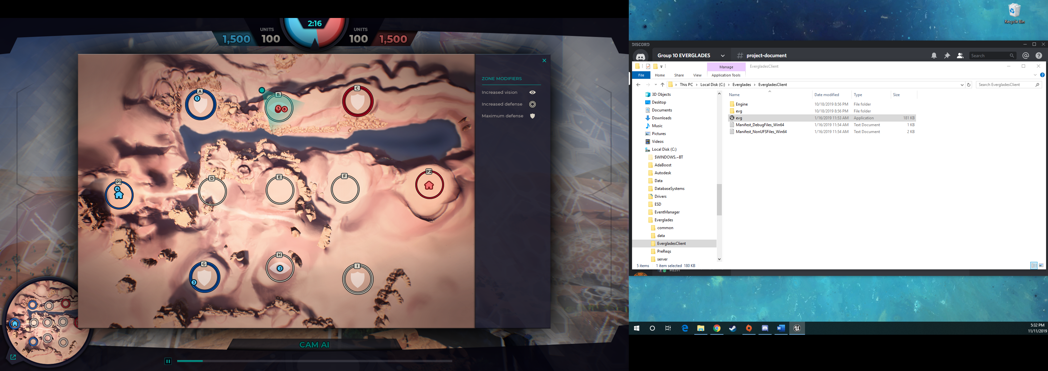

Figure 15: Default Map Visual

These node circles are dynamic objects drawn using hardcoded locations. This will be changed so that the circles are drawn by using the x and y coordinates of the list of random map nodes that will be included in the Telemetry data file. A symbol is also added to this view if the node is either a watchtower or a fortess. This info will also be stored in the node list and will be used to draw the appropriate icons.

Procedurally Generated Game Board

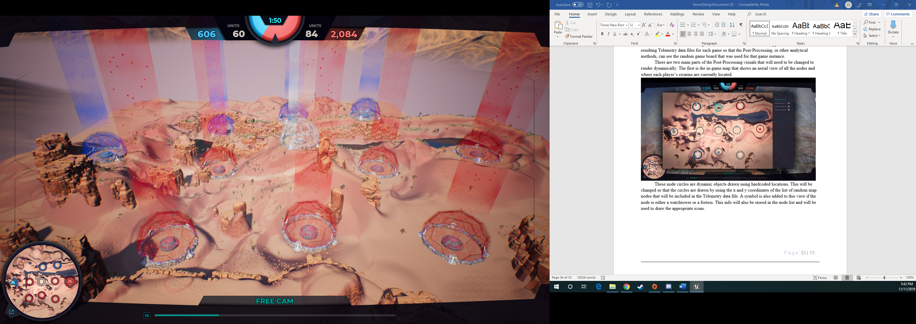

Figure 16: Default Map Generated

The second part of the Post-Processing that will need to changed to load dynamically is loading of the in-game 3d node assets. These node domes are currently placed manually by using the x and y coordinates of the default map layout. The location for each node assets can be calculated by taking the given x and y coordinates from the Telemetry data file and scaling it up to the size of the 3d environment. The game server does not take elevation into consideration so the z coordinate of each node asset is just manually set depending on the default location for the nodes. As a result, some nodes shown with a much higher elevation than others visually despite this having no impact on the outcome of the game.

Procedurally Generated Game Board

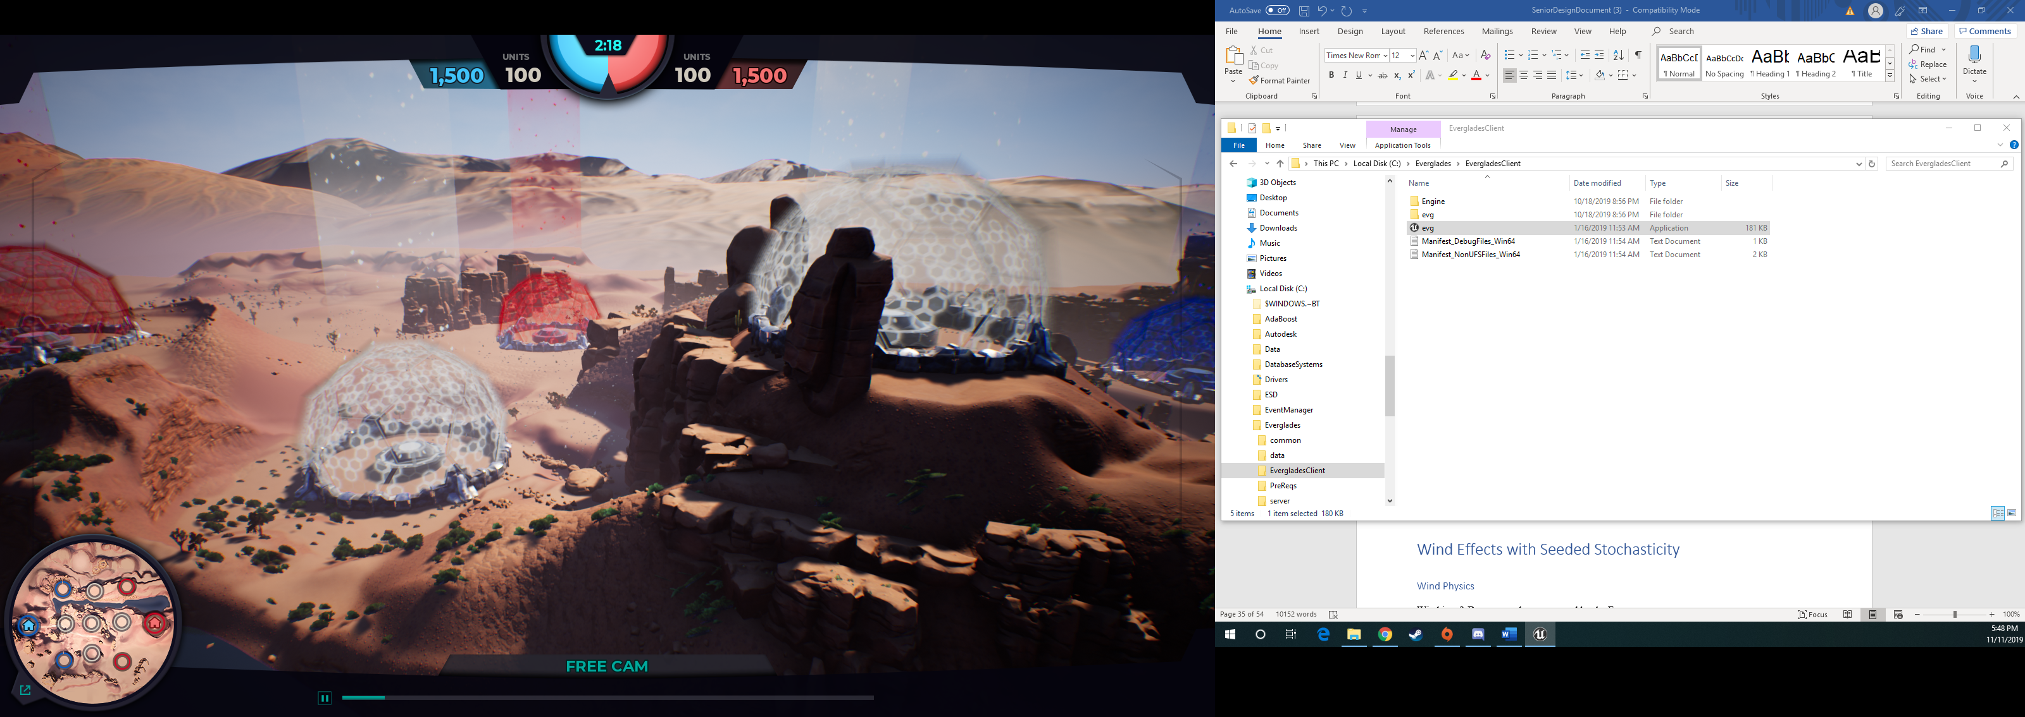

Figure 17: Differing Node Elevations Example

The z coordinate for each of these dynamically rendering node assets will need to be set based on the elevation of that location on the game terrain. The maximum elevation will need to be retrieved for that x and y location of the game terrain so that the center of the node asset can be set to be at that elevation. Some nodes are currently overlapping with parts of the map terrain such as rocks and mountain sides and this may want to be limitted during the dynamic rendering. After the elevation of the random node location is found, a check can be done to look at the elevation around the center of the node asset to see if there is a drastic increase in elevation that happens within the radius of the asset. If there is, the node asset could be shifted slightly to minimize the amount of overlap with the terrain. This would technically show the node at the incorrect location of where it actually was during the game processing, but since the entire game is run before the post-processing visuals, this has no impact on the outcome of the game so it will be fine to include for a more clear visual.

Wind Effects with Seeded Stochasticity

Wind Physics

Wind in a 2-D space can be represented by the Force vector,

**F = <x,y>**

where x is the Force in the x-direction and y is the force in the y-direction. The direction of any two nodes can also be represented by a Force vector although this one is the unit vector,

**U = <a, b>**

The representation between these two vectors can be shown in the diagram below,



In a 2-D representation, the only value of worth is the Fx or Force in the x-direction. For any orientation of U and V, the x component can be found by first finding the dot product between the two vectors to determine the angle between them,

cos(theta) = U•V / (|U||V|)

After that it’s just a matter of inputting the result of the dot product into Fx=F cos . In the simplest interpretation of this, the direction of a vertex can be ignored. If this is the case, then the previous calculations do not need to be done. Indeed, the only value that needs to be known is the x-component of the V vector. While this kind of representation is simpler, it can offer more variety when training an AI Agent.

Wind in game board will be a modifier that will potentially slow or increase the movement capabilities of a swarm depending on which way they are travelling. For example, if the wind is blowing in the direction that a unit is a traveling, then that unit will receive a movement speed increase when traveling across those vertices. The opposite holds true for a unit traveling in the opposite direction; they will receive a movement decrease. The hope is to also have the wind’s force influence the accuracy of drones when attacking. These modifiers will be represented by a percentage that is derived from dividing the force by the maximum force that can be achieved by a wind vector. This percentage will then be applied to any units moving over that vector. For example, if a unit can move say 8 units in one turn and there is a -50% movement speed modifier when moving over a given vertex, then that unit will only be able to travel 4 units when going over that vertex. When sent as telemetry data, the data can be stored in some JSON package that specifies the wind modifier percentage between each connection of nodes.

Stochastic Seeding

Stochastically seeding in C++ can be done through the use of a built-in function called *srand().* The function is a pseudo-random number generator that is initialized using some integer seed value. For every different seed value inputted into *srand()*, the function is expected to generate a different sequence of numbers using the *rand()* function. It holds that if *srand()* is run using the same seed, it will return the same sequence of numbers. Also, if the seed value is set to 1, the generator is reinitialized to its initial value and produces the same values as before any call to either *srand()* or *rand()*. In order to generate random-like numbers, *srand()* is usually initialized to some distinctive runtime value, like the value returned by the *time()* function. This is distinctive enough for most trivial randomization needs. Below is an example of how *srand()* works:





As shown from the output, when *srand()* is run using 1 as its input, it returns the first number again. The application of this kind of randomness is very beneficial in the application of wind generation. For a 2-D board, *srand()* would be used by generating a seed and then generating a random number that dictates the wind for each vertice in the game board. The seed would be sent in the telemetry data so that it can be stored.

Reinforcement Learning Support

# Description

Another Nice-to-Have feature for our project is including some extra support for Reinforcement Learning training. AI Agents that learn through Reinforcement Learning have two main processes for how they can train. They can train while playing the game, and they can train by looking at the results from a completed game.

Below is a simple diagram showing the basic overview of how Reinforcement Learning functions. The Environment feeds information about the State of the game and a Reward to the Agent which uses this info to choose an Action to be sent back to the Environment. The Reward sent from the Environment would be something like Points earned after the previous action. When an Agent is training while playing, it will receive the State and Reward information from the Environment, then use that information to decide what action should be taken. This action will be sent back to the Environment and the result of the action can be observed the next time the Environment feeds the Agent the State and Reward information. When an Agent is training off a completed game, instead of the Agent deciding on an Action and sending it to the Environment, it will just observe the Action that was taken that turn and the result of that action. This information will then be used to train the Agent.

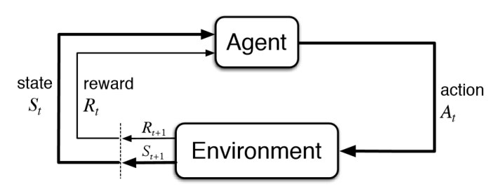

Training while playing the game will not require any new additions to be able to function properly, and a feature already exists in the Unreal Engine UI that gives the ability to run n-amount of game simulations with the selected AI Agents. This gives the user training the AI Agent an easy way to simulate many game sessions without the need for interference after every game.

Reinforcement Learning Support

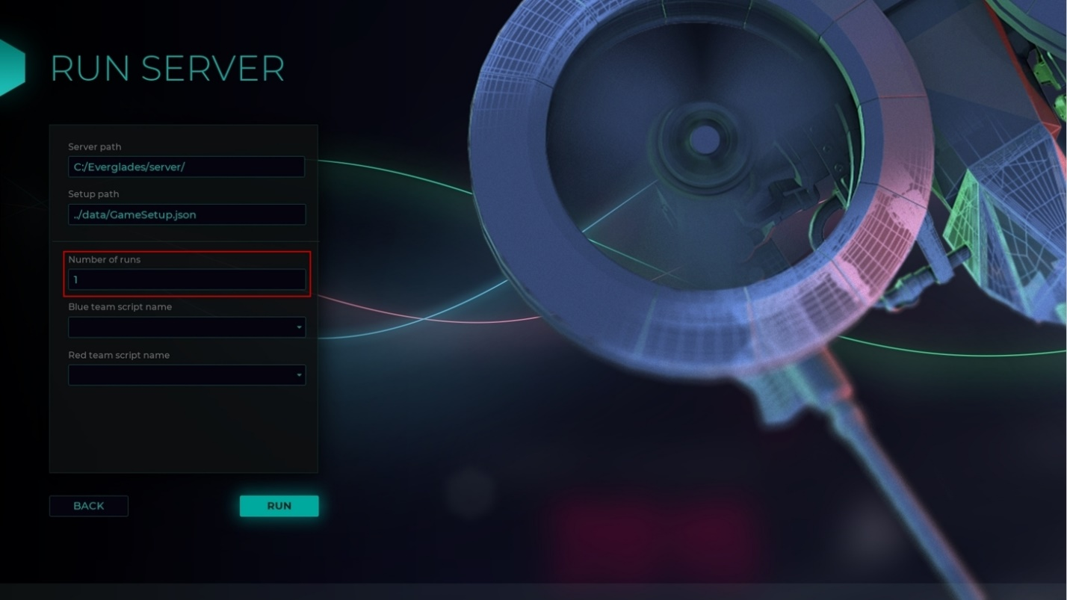

Training an AI Agent using the data of a completed game could be done in multiple ways depending on how the AI Agent is currently programmed to train. The training could be fully processed by the AI Agent where it would take in all the telemetry data of the game at once and parse this information into individual moves that can then be process to the what action was taken and what the result of the action was. If this is the method chosen, the only feature that could be added on the Game end is adding the ability to initialize this training from the Unreal Engine UI. Another section could be added that would allow the user to choose an AI Agent to train and the telemetry data to train off. Another method that would require more of the processing to be done on the Game end would be to have the Game split the telemetry data up into the individual turns and results and feed this data into the Agent turn by turn. This method could use the same new section in the Unreal Engine UI as mentioned above but more processing of the data would be handled by the Game end.

The image below shows a mock-up of how the new Agent Training section could be added to the home page of the Unreal Engine UI. Clicking on this section would go to a new page that would give the user the option to choose an AI Agent and the Telemetry data to train with.

Reinforcement Learning Support

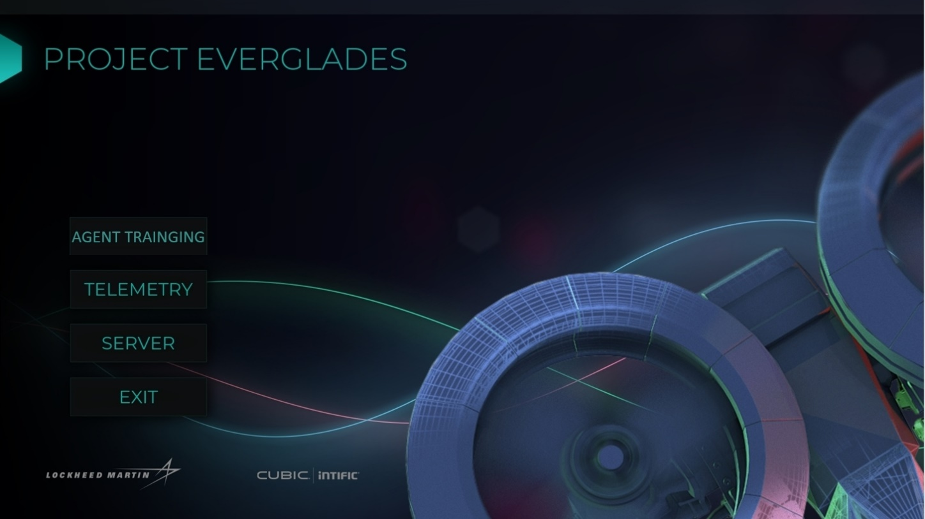

Including this new feature could help speed up the training process for AI Agents and give the ability to train off completed games which could help some Agents train in ways that they previously could not.

This feature could also be used by other current and future senior design groups when creating their own AI Agents. The Everglades game is intended to be used as a learning tool for people to learn and practice using Reinforcement Learning. The game will be used for senior design projects in future semesters and possible at different schools than just UCF. Having this new support fore Reinforcement Learning could help provide a starting point for programming the training portion of other student’s Agents or just give them another way to train their agents.

Drone Death Animation

Anatomy of an Explosion

Creating a custom explosion animation is Unreal requires an understanding of how to work with particles and textures. It also demands knowing how to animate and manipulate said particles and textures. An explosion is composed of two primary parts, the smoke and the blast. The smoke is the part usually surrounding the explosion after it has blasted, and the blast the fire-y center. An explosion also contains three essential steps, the initial blast, the outward expansion, and the final dissipation. The following picture, while 2-Dimensional, still shows the three stages:



The first two pictures show the initial explosion, indicated by spikes in this representation. This step should attempt to highlight the direction and power that explosion has. It should therefore be fast, as it contains the most power. The next step is the expansion step which occurs in the subsequent 3 frames. Frame 3 serves as a transition step between the initial explosion and the outward expansion, as they are directly connected. The next two frames really highlight what the outward expansion step really is about. This step is to show the sheer magnitude of the explosion, due to the fact that it is at its biggest in this step. This also shows the clear distinction between the smoke and the blast. The smoke is the outer rim of grey and the blast is the red plume within it. After that, the outward expansion transitions into the final dissipation. These, like the last two steps, are directly connected. This is the very end of the explosion, and it should end with the blast and the explosion dissipating into nothing.

Unreal Implementation

Implementing a convincing and satisfying explosion into Unreal requires several steps. In order to create the smoke effect, a cloud texture, like the one shown below, is used to represent the cloud effect. This texture will serve as the base texture that affects will be applied to.



Now the texture has been chosen, the next step is to manipulate it using particles. Particles are an integral part of visual effects in Unreal. More specifically, Particle Systems are essential for creating things like explosions, smoke, and even rain. A particle in Unreal is a point in space. With a Particle System, these individual Particles can be manipulated. Particle Systems consist of a component called an Emitter. An Emitter is responsible for emitting particles. These Emitters possess components called Modules. Modules control specific properties of spawned that are being spawned by the emitters. This can be anything from their color to their direction to even their opacity. Below is an Emitter given two modules, one to make each particle look like a red circle, and another giving it a random velocity.



For an explosion effect, several adjustments need to be made to the standard Particle Emitter. First of all, a velocity must be applied to a Particle System. This will emit particles outward like it does in an explosion.



After applying a velocity to the particles, the next step is to change the amount of loops that an Emitter performs. By default, an Emitter will loop indefinitely. Changing the value to 1, it only performs the operation once. This is good for things like explosions which only occur once and dissipate.



Applying Explosion to an Entity

Making an entity in any game engine die requires several steps. The first step is to confirm that an entity has died. In the case of the Everglades project, it entails checking when the unit is at zero health. If a unit meets this death condition, the next step is to despawn the unit. The final step is to replace the despawned unit with the explosion. In this case, that would involve replacing the despawned unit with the Particle Emitter that produces the explosion. Unreal makes this very easy with the OnDeath event in Unreal. Below is an example of creating a simple particle effect and connecting it to an entity's OnDeath event:







To put it simply, this event handles all of the events at once. The Event only occurs if a unit has died, which handles the first step. The next step is handled by DestroyActor, which destroys the entity when it has died. Finally, “Spawn Emitter at Location” will execute the explosion wherever the unit has died.

One final point should be made about implementing explosions in Unreal for units in this project. Since the drones are grouped into swarms, the graphical cost for exploding each swarm individual could prove to be too much. Therefore, it might prove to be better to despawn all the units of a swarm and then only produce one large explosion for the entire swarm. This will prove to be more resource efficient which will allow it to run on lower-spec systems.

Unit with Sensor

Purpose

The purpose of creating a new unit with an attached sensor is to introduce new elements of strategy to the game. This may alter the way that AI agents play the game, provide new strategies, or create new challenges.

The sensor will be designed so that it will be capable of gathering data from the environment. The current project will not be able to gather this data during gameplay because visual elements are post-processed and therefore do not exist while the game is executing. Thus, the unit will be given a unique bonus like existing units in the game.

Sensor Background Research

The sponsor gave the team three options for sensors to implement: infrared (IR), electro-optical (EO), and synthetic aperture radar (SAR). Only one of these will be selected, implemented, and used within the game. Each sensor has unique advantages and disadvantages. No matter which is chosen, it must be configurable via input file.

## Infrared

Infrared sensors detect electromagnetic radiation with wavelengths between 0.7 μ (microns) and 1000 μ. These wavelengths are longer than visible light, lying beyond red in the color spectrum, but are shorter than microwaves. A large contributor to IR emittance is thermal energy. Thus, all objects that are not at Absolute Zero radiate IR energy.

This energy passes through a medium, which in most cases would be air but could also be a vacuum or a liquid. The sensor collects and focuses this energy with lenses and mirrors composed of different materials depending on the specific needs of the sensor. The IR energy can be used to create a signal that can be interpreted in different ways [1]. An example of a visual representation of thermal infrared can be seen in figure 3.



*Figure 5: An infrared image*

The above description of an IR sensor that detects thermal energy, is an example of a passive sensor. It is one of two main types, the other being an active sensor.

Passive sensors do not produce their own infrared signal but detect IR from objects in the field of view (see figure 2). They are useful for detecting heat and motion but may not work if the ambient temperature is greater than or equal to the target’s temperature. Indeed, it would be difficult to detect the presence of a human standing in a desert during the day if the air was 100°F. Yet, the same person standing in the desert at night, when there is a significant difference between the temperatures of their body and the air, would easily be detected.

Active sensors provide their own electromagnetic source either through a light emitting diode or a laser. In some types, the detector is located a distance away from the emitter. Objects are detected by passing between sender and receiver, interrupting the signal.

More appropriate for this project’s “drones” would be a reflective sensor. Here, the emitting source and sensor are near each other and facing the same direction. The emitted signal is projected towards a target which reflects the energy back toward the sensor’s detector (see figure 2). The signal is processed to produce the desired data.

Active sensors can be used to detect objects, find distance to an object, detect movement, and detect surface features. Interpreting how different wavelengths of a signal are reflected by a target can even be used to infer a target’s material. Despite these useful features, an active sensor can easily be located due to its emitted IR signal.



Figure 6: Active and Passive sensors

## Electro-Optical

Electro-optical sensors detect light in the optical spectrum, with wavelengths between 0.01 μ and 1000 μ. This includes ultraviolet radiation, the visible spectrum, and infrared. Indeed, IR sensors are a type of electro-optical sensor. For the purposes of this project, EO sensors would be restricted to the visible spectrum in order to differentiate them from IR sensors.

## Synthetic Aperture Radar

Synthetic aperture radar is used to create detailed images of objects and terrain. It can accomplish this independent of weather conditions and time of day (see figure 4). It also has a much larger range than the other sensors.



*Figure 7: 1976 Synthetic Aperture Radar image of Willow Run Airport and vicinity*

It is an active sensor that operates by emitting a microwave pulse toward a target which is reflected to the SAR sensor. The time it takes to receive this pulse is used to calculate range. The width of the pulse determines the resolution, with a wide pulse resulting in coarse resolution and a narrow pulse creating a fine resolution. In order to gather any meaningful data, one would need a narrow pulse. However, this would require a very large antenna, which is very impractical. By emitting pulses as the SAR travels in its straight-line path – called azimuth - and then processing the data, the result is the same as if a large antenna was used. “The distance the aircraft flies in synthesizing the antenna is known as the synthetic aperture.” [3] (see figure 5)



Figure 8: Synthetic Aperture Radar

Moving objects can pose a problem for SAR, resulting in the target being shifted in the image due to the Doppler effect. Moving toward an object produces a positive Doppler offset, while moving away from an object produces a negative offset. If an object is moving, it can interfere with these measurements. There are several solutions to this, including the use of two SAR sensors spaced some distance apart, parallel to the azimuth. Because these antennas are mapping the same area, object movement can be detected and accounted for. [4]

Sensor Choice

Deciding on the type of sensor required a balance between the feasibility of implementation, the benefits of the type of data that can be collected, and its overall uniqueness. Ultimately, an infrared sensor was chosen for its useful thermal and distance detection as well as the capability to provide a post-processed thermal view. The electro-optical sensor, being restricted to the visible spectrum, is not as useful as infrared, which can detect targets behind certain materials as well as detect invisible heat signatures. SAR is useful for terrain mapping but is not as useful as the tracking capability of the IR sensor. It is also more complex, especially if it is designed to detect moving targets.

New Unit Class

*Recon* is the name of the new unit with infrared sensor. It will have its base properties defined in “UnitDefinitions.json” like the other units (see figure 6). The IR sensor properties will be developed and added to the recon class.



*Figure 9: UnitDefinitions.json showing unit class properties*

Simulating Thermal Data

To simulate the thermal properties of objects that exist in the real world, each object in the game will be assigned an electromagnetic wavelength. These values will mimic wavelengths found in the real-world for corresponding objects, be it a tree, grass, a building, or a machine.

Searching for infrared wavelengths of objects yielded few results but this was remedied using *Wien’s Displacement Law* (see figure 7).

λmax =

Figure 10: Wien's Displacement Law

In this equation, λmax “represents the wavelength at which maximum radiation is emitted…” [7], *T* is the temperature of the object in degrees Kelvin, and *constant* is the value 2897 μm. Thus, only object temperatures need to be researched to determine their infrared wavelength.

Simulating Reflectance

An IR wavelength property for heat emissions will be useful for passive sensors, but not for active. In the interest of realism, it would be exciting to assign reflectance properties to each object. The wavelength of the IR emission would reflect on the material and a certain value would be detected by the sensor. The reflectance data would be stored in a *dict* as an object property, with the wavelength as the key and the reflectance as the value. A line trace would then return a float value showing a ratio of reflectance specific to that wavelength.

With consideration to cost, a collection of free reflectance data needed to be acquired. Spectral Library 7 from the United States Geological Survey contained much data covering vegetation, soil, artificial materials, minerals, liquids, coatings, and organic compounds. Despite the trove of data that it contained, some objects in Everglades need to have approximations, as the exact data could not be found.

At this time, the project team does not have access to the Unreal project files, so a visual inspection was made of the game environment to determine the object types and which spectral data they could correspond. Included in the spectral library were gif plots showing the reflectance curve for each object.

Different types of cacti appear in the landscape, or perhaps cacti at different stages of their lifecycle. The spectral library only contained information on one cactus, the *Sata Rita purple prickly pear cactus*, which these do not resemble, but should be a close enough approximation.

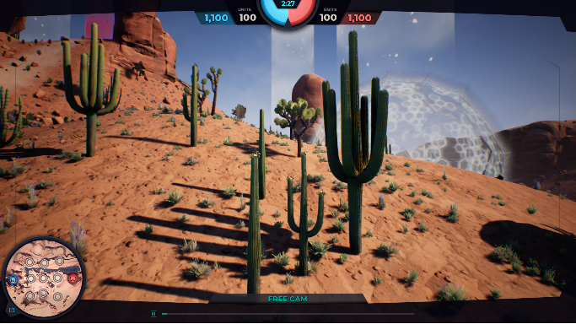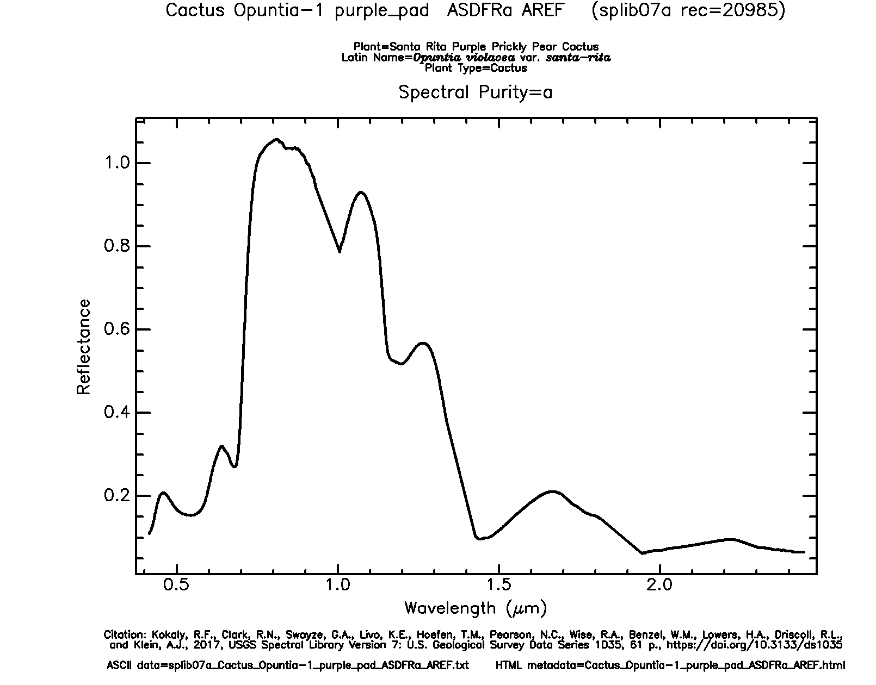

Figure 9: In-game cacti and associated reflectance plot from spectral library

Shorter grass in Everglades most closely matches *Idaho fescue* in the data.

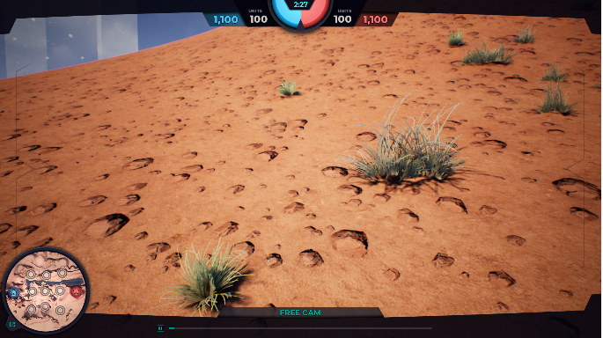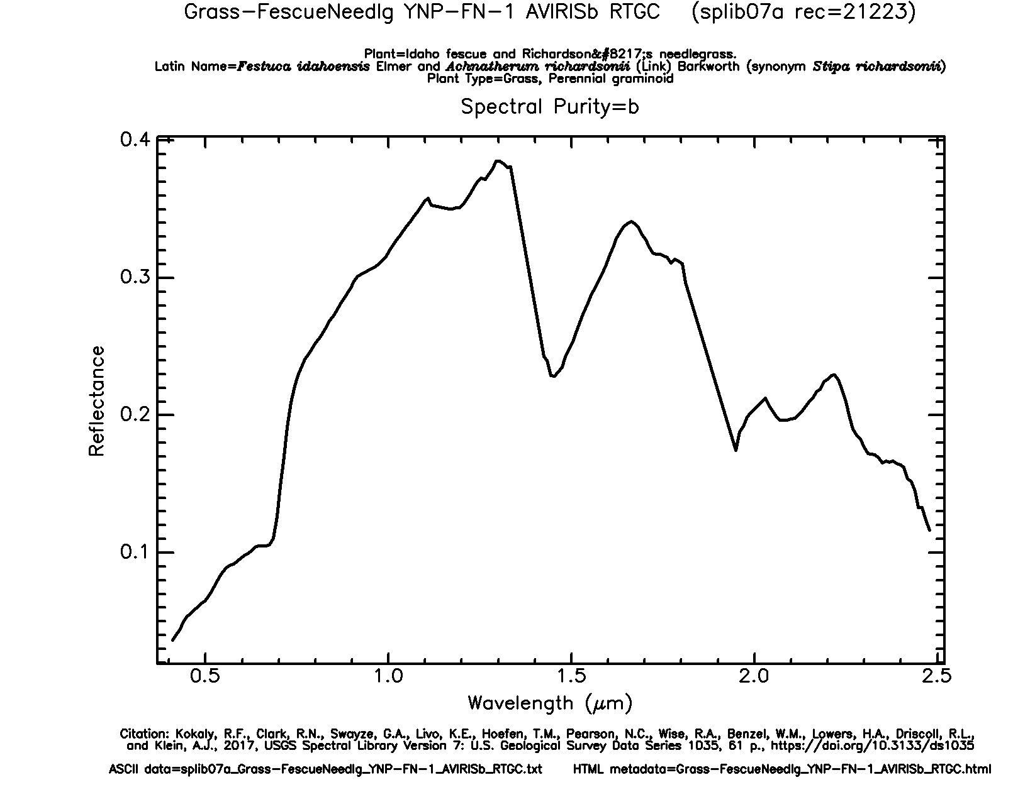

Figure 10: In-game short grass and associated reflectance plot from spectral library

This tall grass or small bush has feathery leaves or flowers on the ends and closely resembles a small *chamise* shrub from the library.

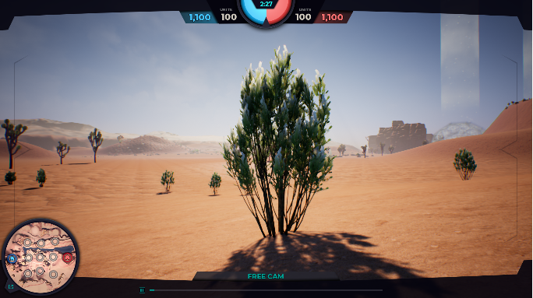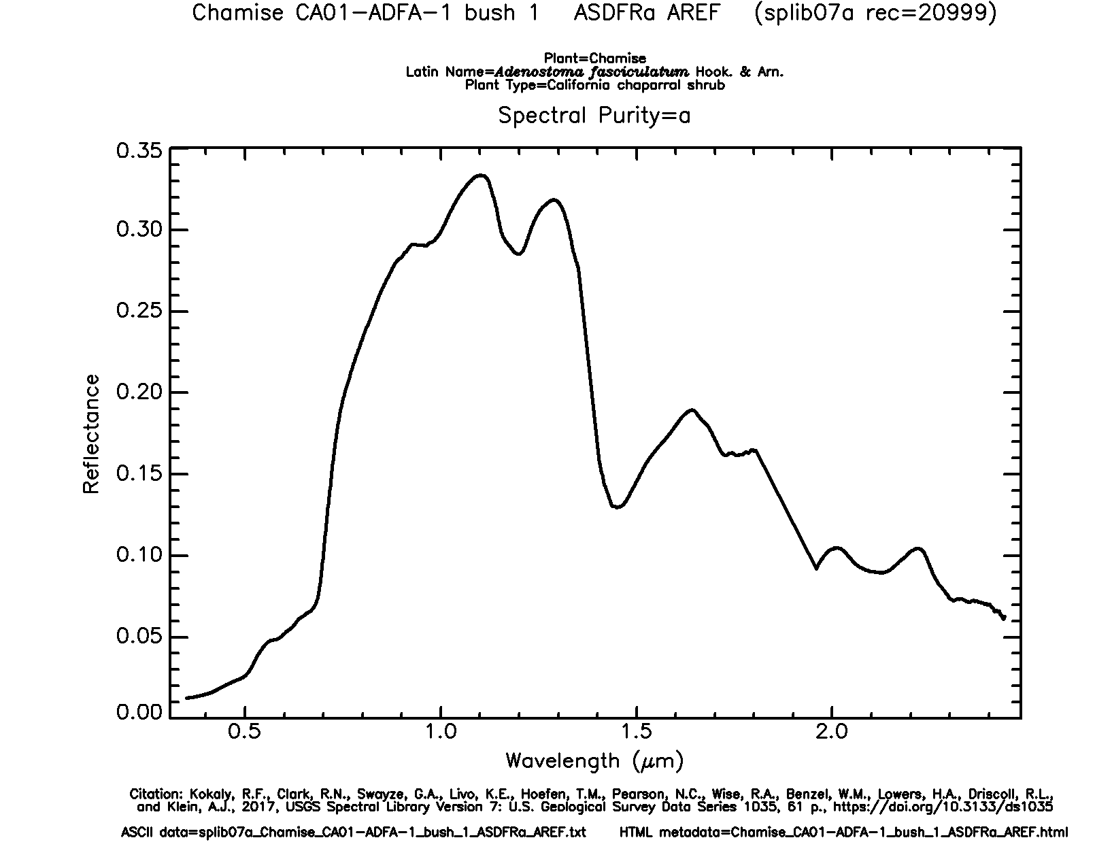

Figure 11: In-game tall grass/bush and associated reflectance plot from spectral library

This shrub appears to have short, pointy leaves with many bare branches towards the base. It looks much like a *sagebrush*.

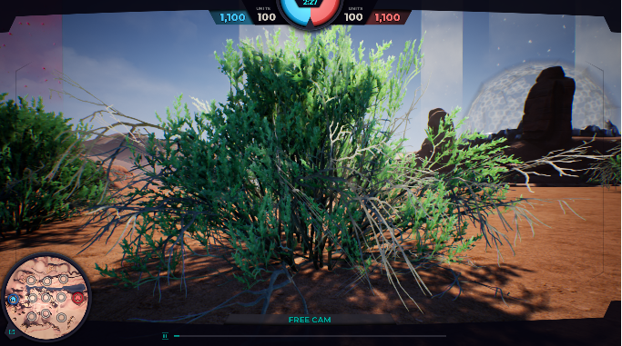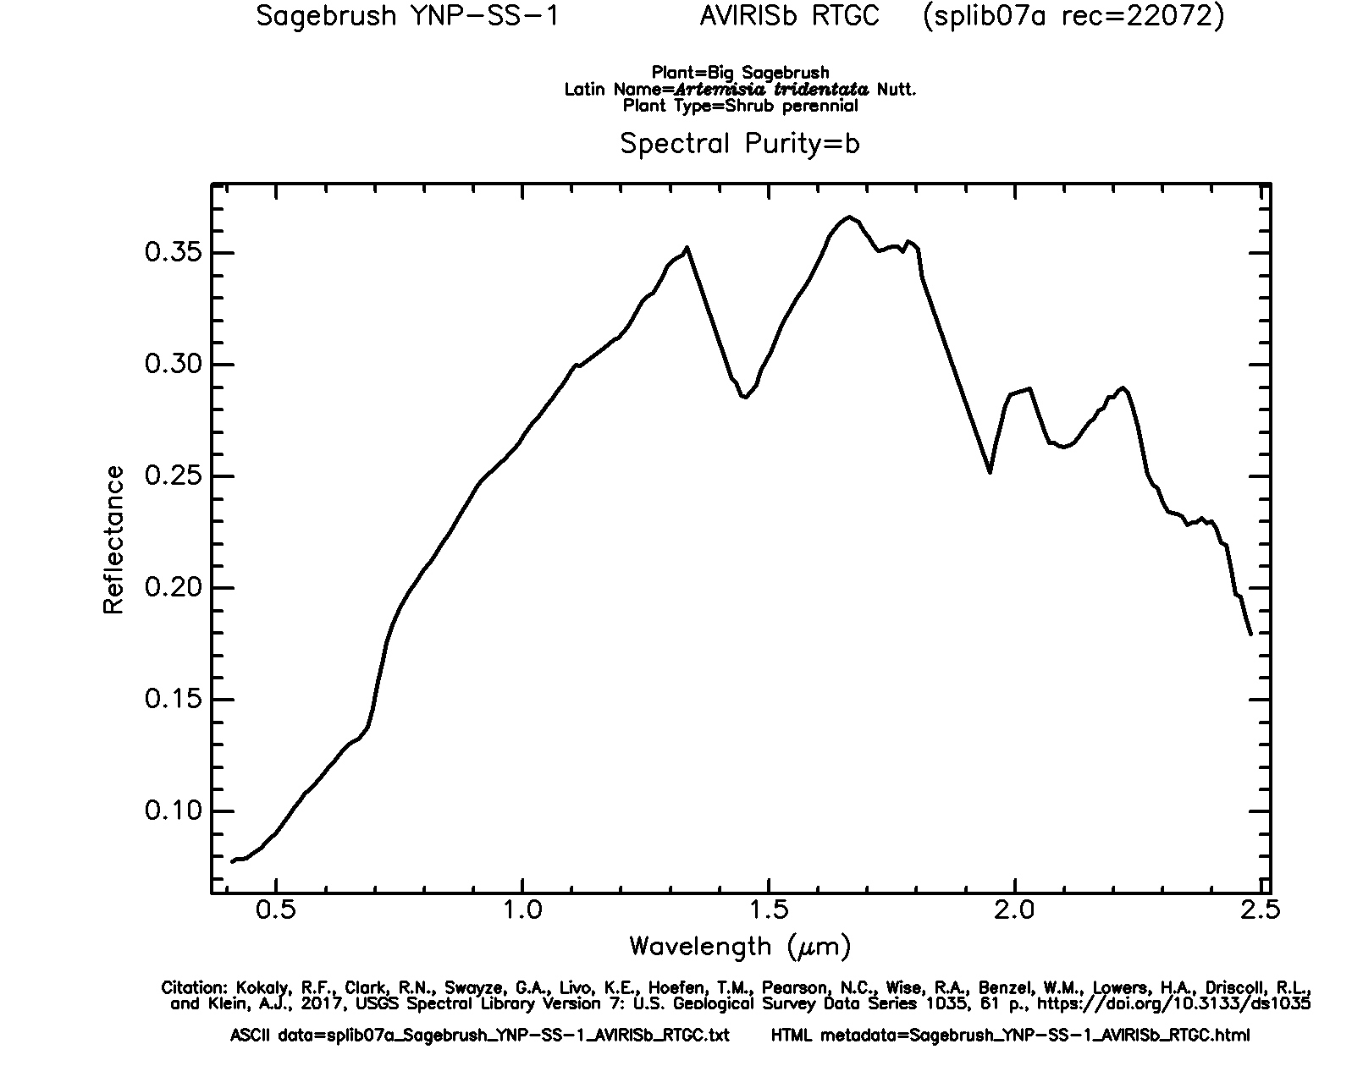

Figure 12: First in-game bush and associated reflectance plot from spectral library

The second bush is like the first but has small deciduous leaves that are more widely spaced on its branches. It closely matches an unflowering *buckbrush*.

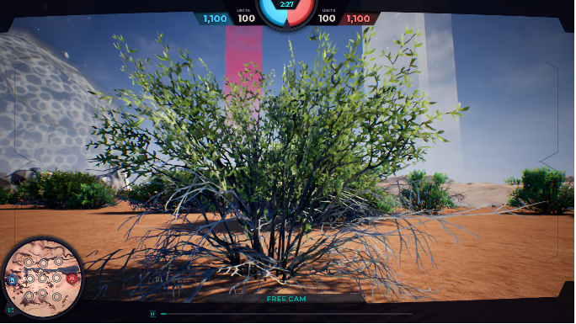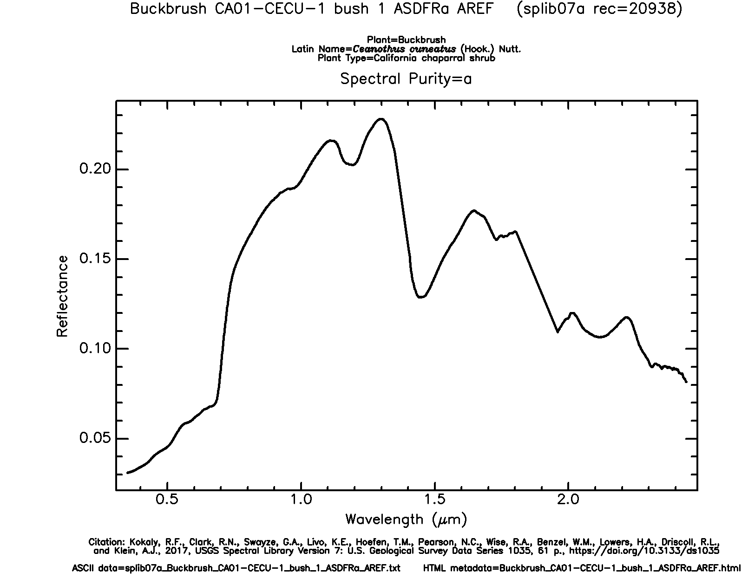

Figure 13: Second in-game bush and associated reflectance plot from spectral library

The game includes groups of yellow wildflowers, matching closely with the features of a rabbitbrush from the data set.

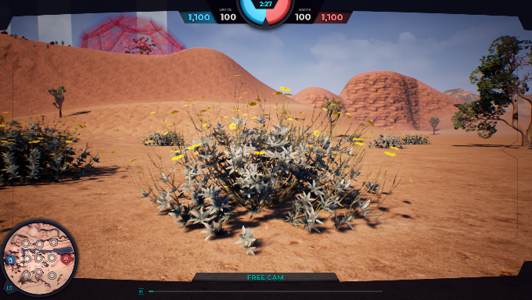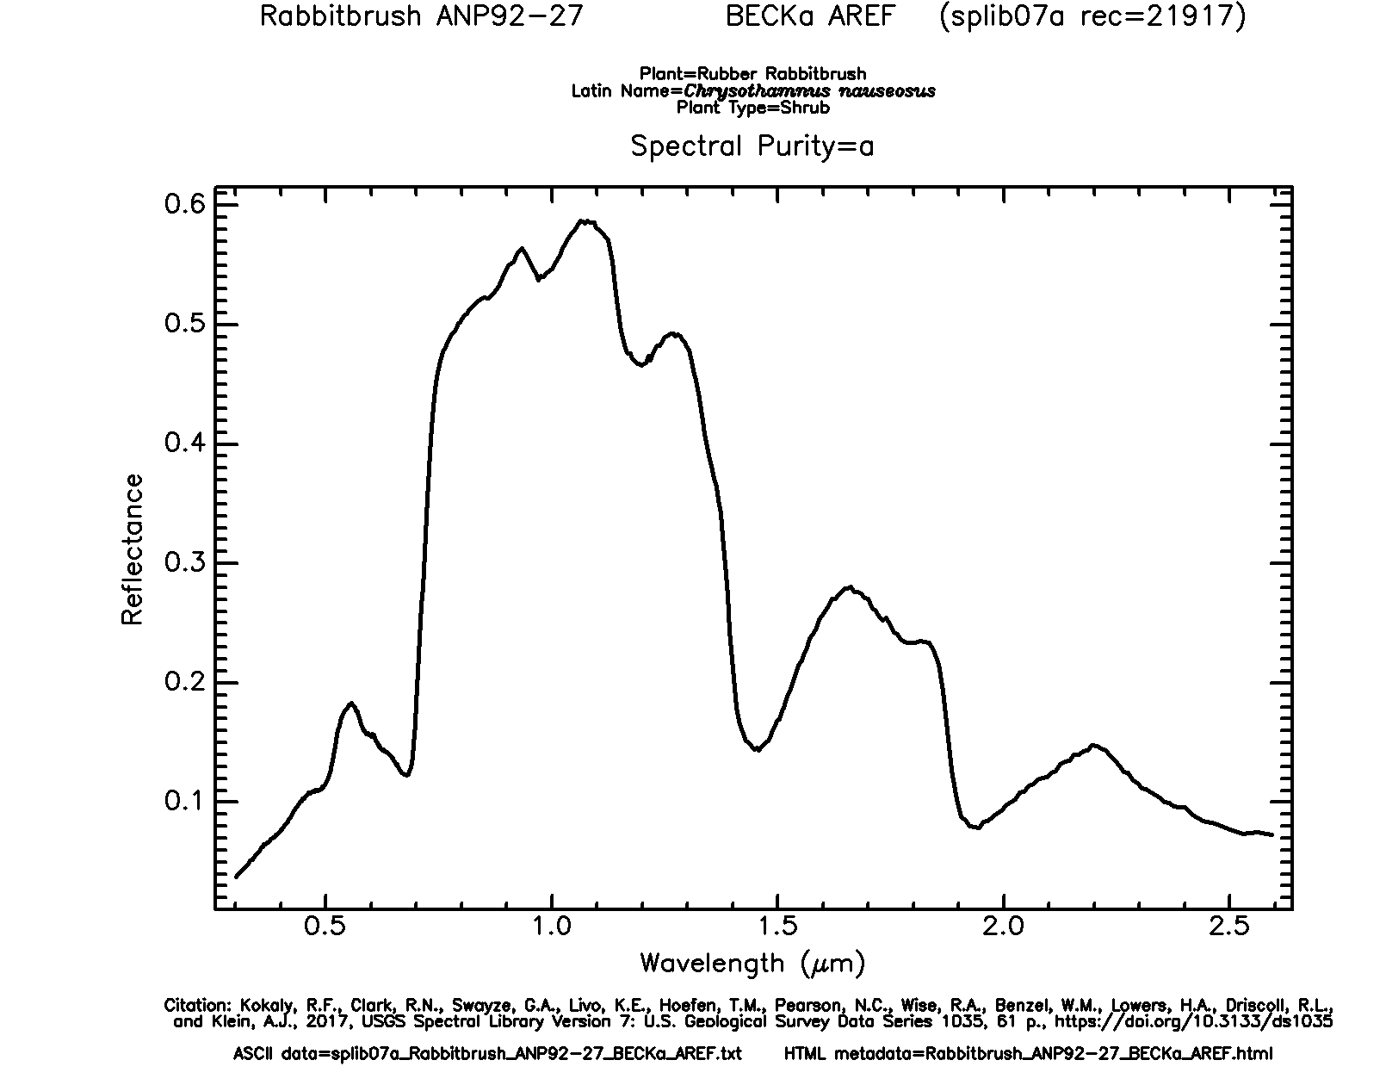

Figure 14: In-game flowers and associated reflectance plot from spectral library

Two types of trees appear in the game. The first looks like a small desert tree without many leaves, resembling a *manzanita* from the library. The second is almost assuredly a *Joshua tree*, which is not included in the library, unfortunately. In fact, there is no tree in the library that comes close to that. Therefore, both trees will use the same reflectance data, since it will not interfere with the game. They have approximately the same size, should they be used as an obstacle in future Everglades iterations.

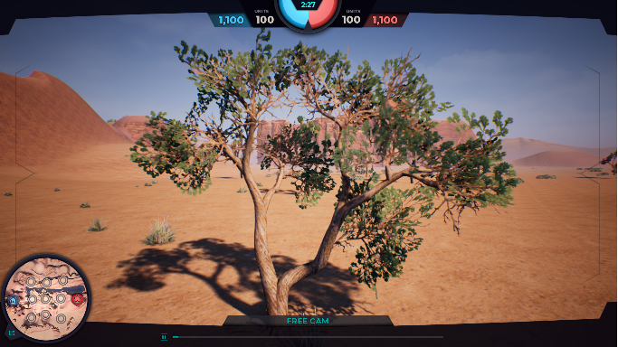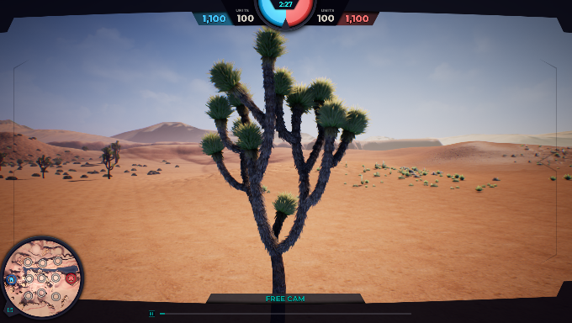

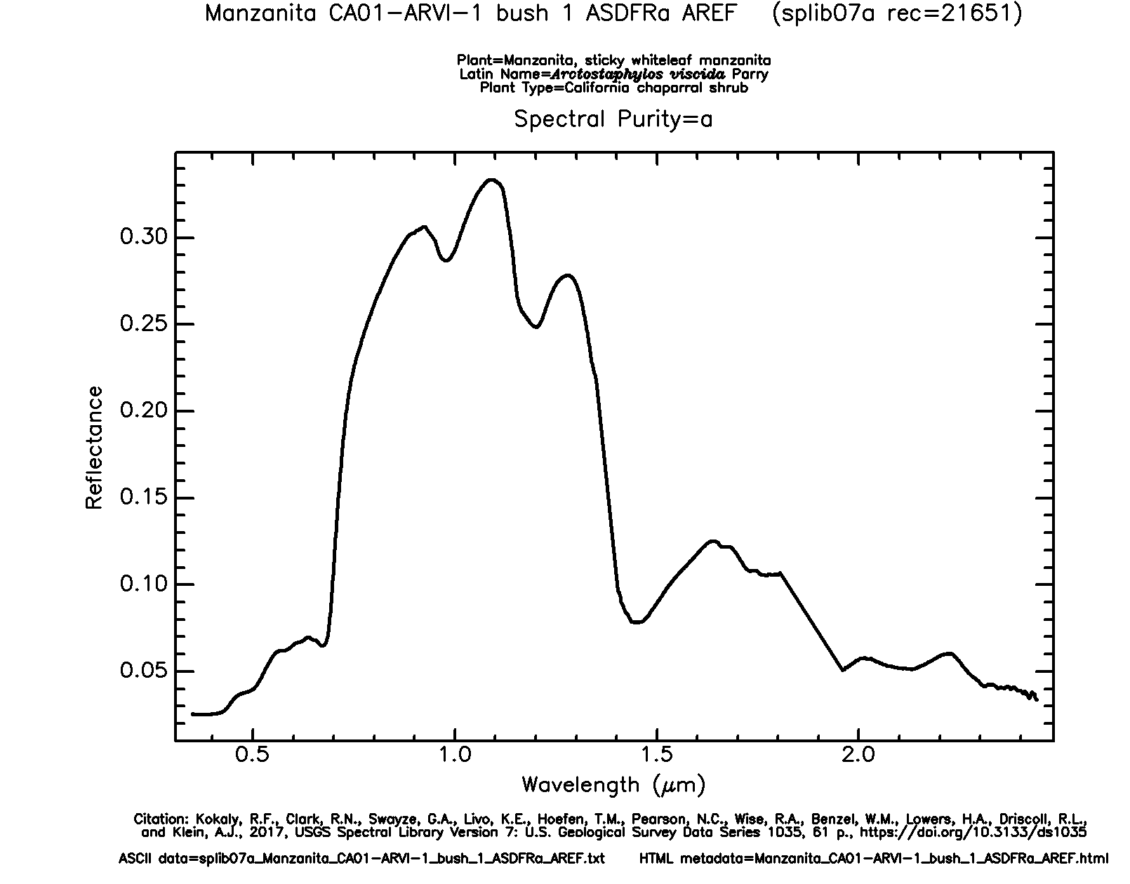

Figure 15: In-game trees and associated reflectance plot from the spectral library

The ground surface appears sandy with rocks strewn about. With the mindset that the terrain would contain a variety of minerals, data from Stonewall Playa was chosen. This data is an average of several different data sets recorded over the same area.

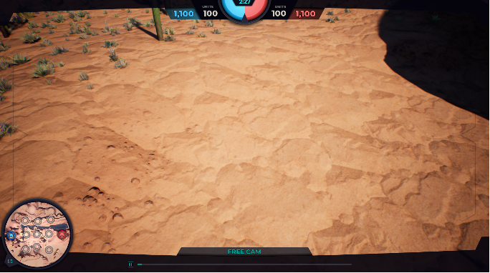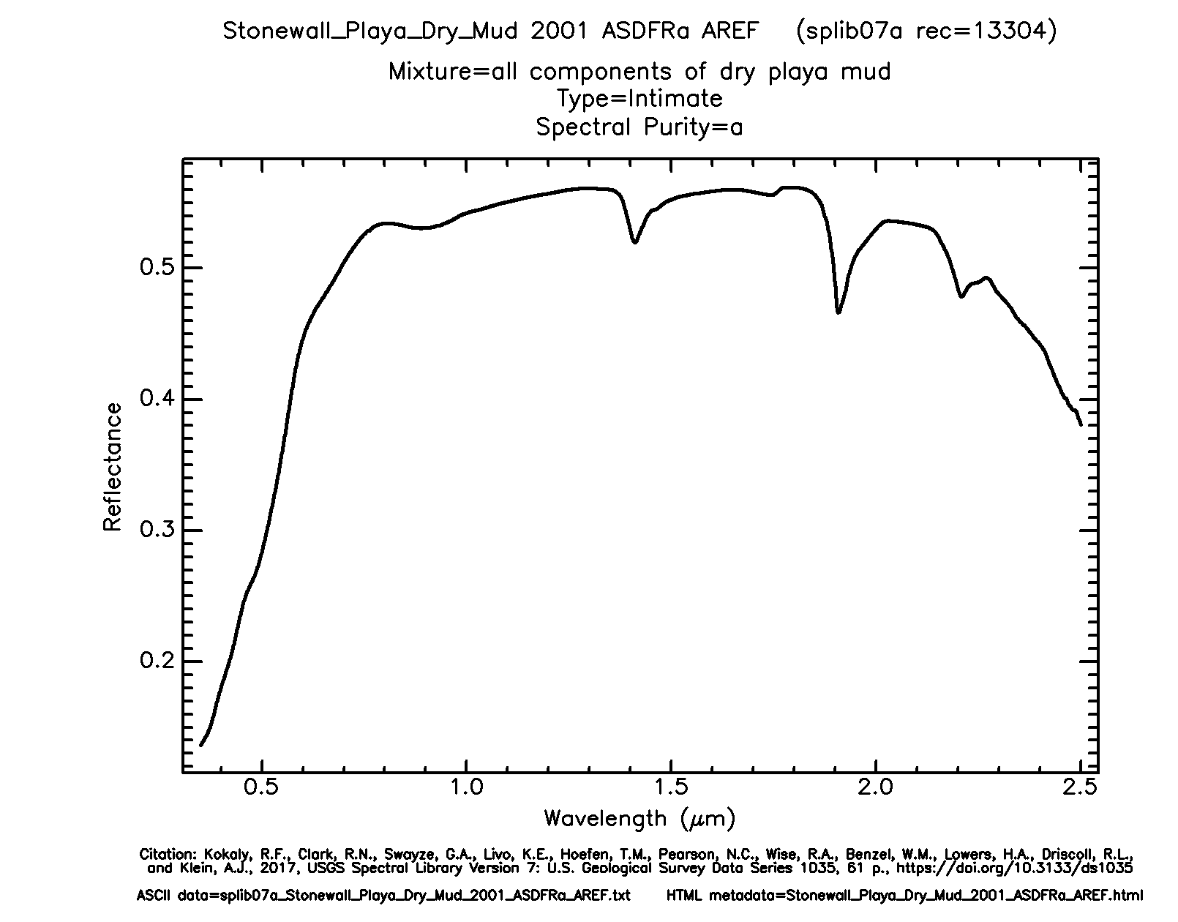

Figure 16: In-game ground and associated reflectance plot from the spectral library

Throughout the Everglades landscape, there are large, rocky pillars. It is assumed that these are made of sandstone, but sandstone is not included in the mineral data from the spectral library. Since sandstone is primarily composed of quartz, this mineral was selected for the pillars.

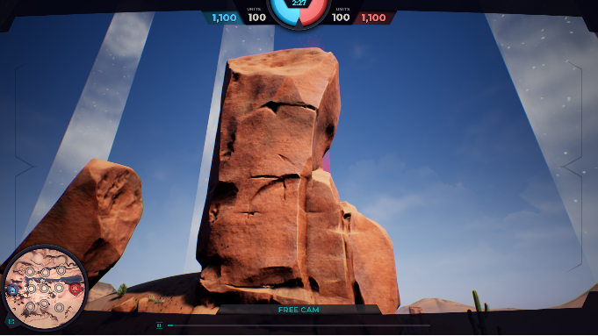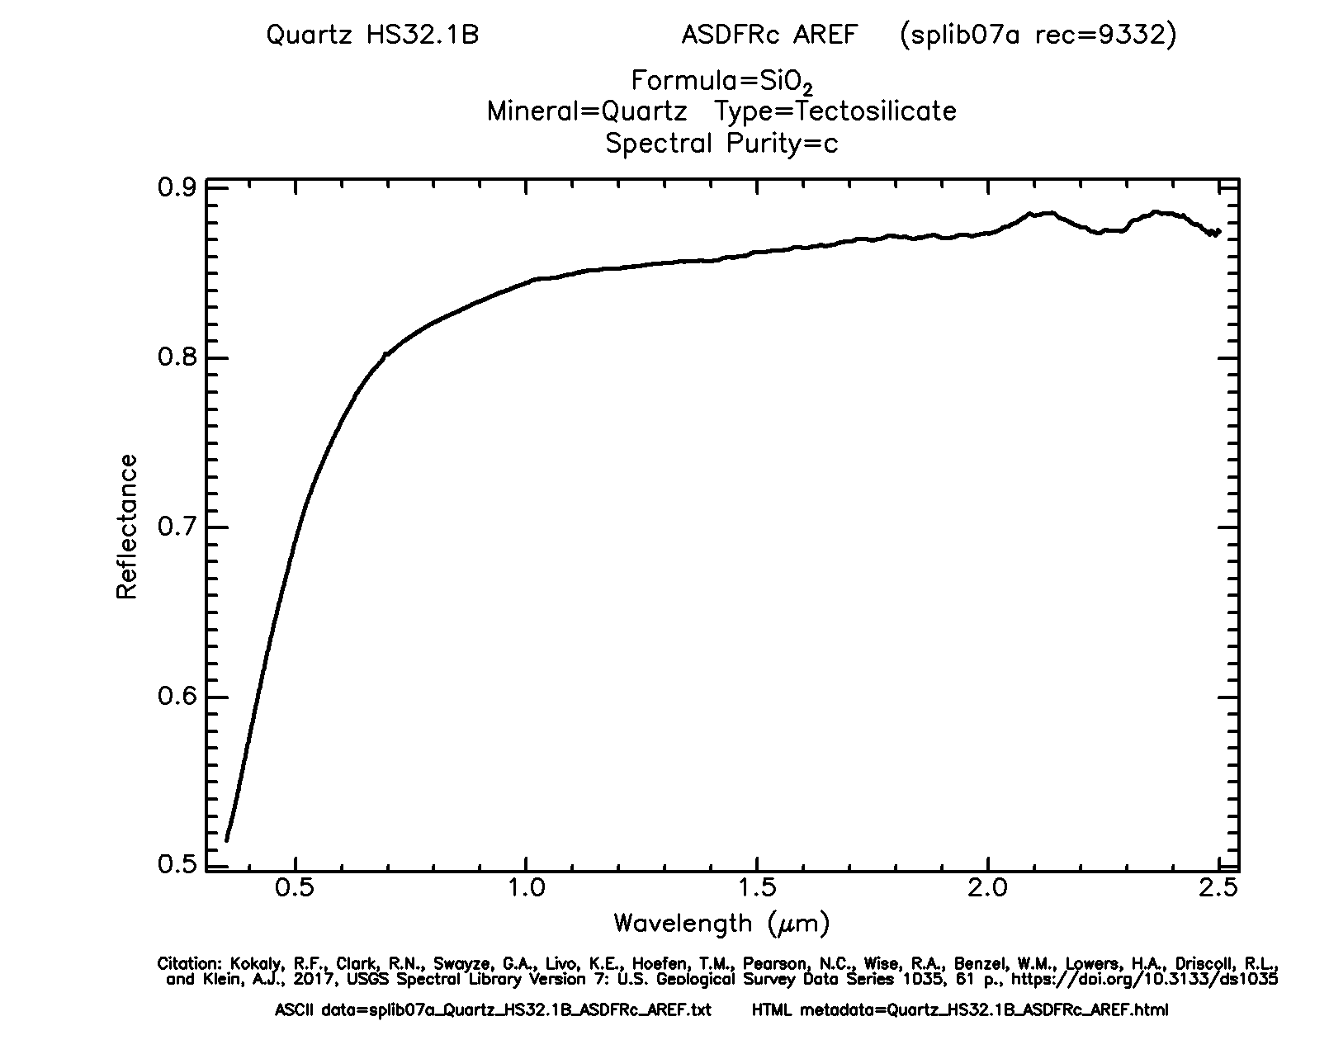

Figure 17: In-game pillar and associated reflectance plot from spectral libarary

Flowing through the landscape is water that is assumed to be fresh. The spectral library does not contain data for pure water, but it does have data for water with dissolved montmorillonite, which is a clay. This would mimic dissolved sediments in the water.

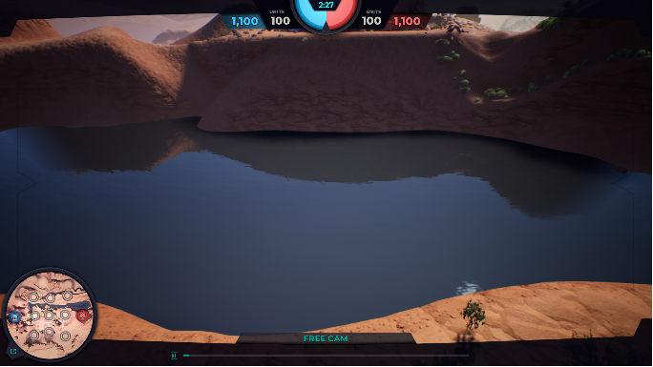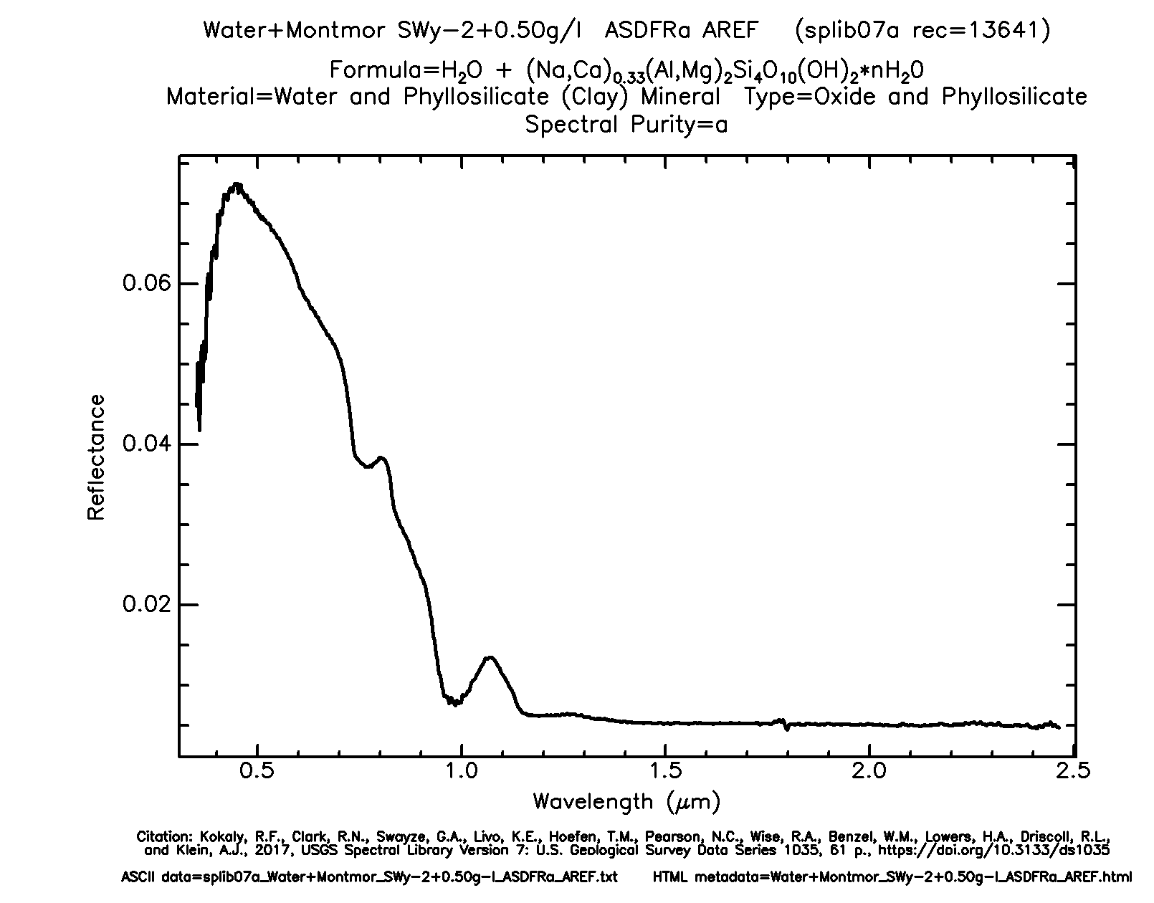

Figure 18: In-game water and associated reflectance plot from spectral library

Game nodes, including home bases, appear to be composed of concrete.

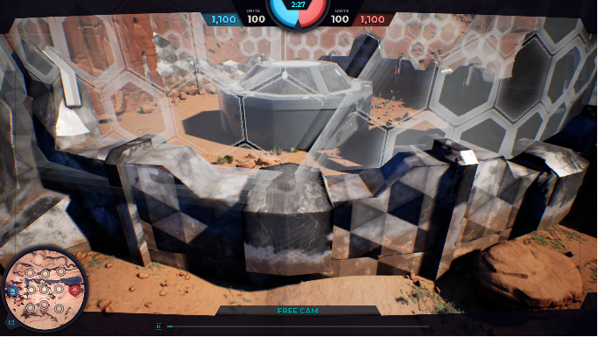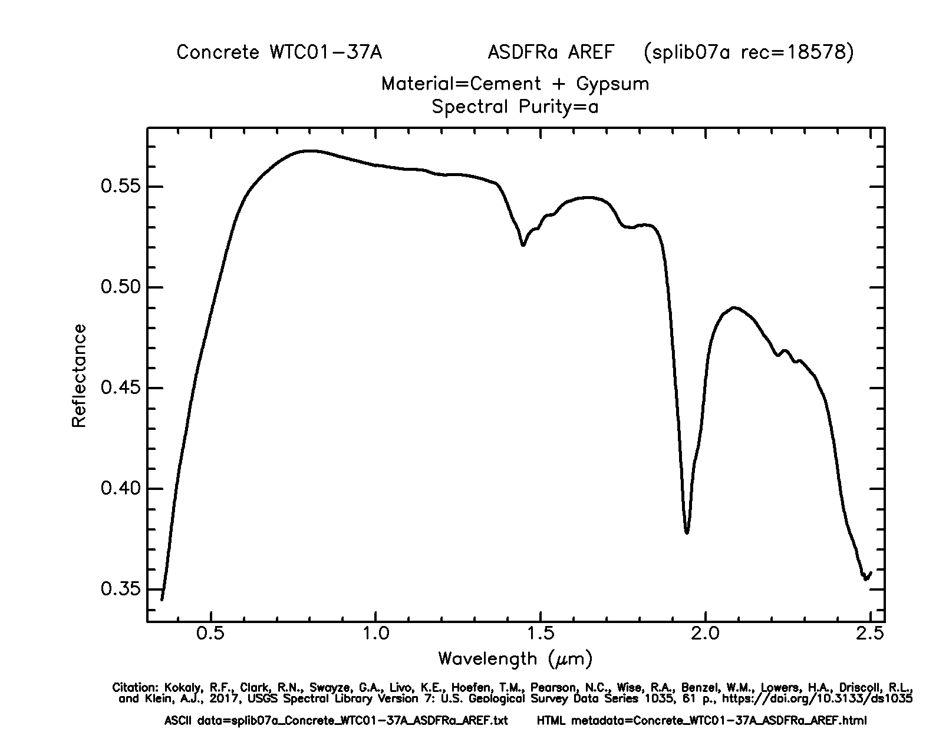

Figure 19: In-game node and associated reflectance plot from spectral library

The three types of units need some way to be differentiated when detected. This would provide the AI agents more information about the compositions of enemy groups that they come across. So, assumptions are made regarding the material of each type.

Strikers are the fastest but also have the least health. It is assumed that they are composed of a light material, such as plastic. HDPE plastic from the spectral library is a strong, but flexible plastic used in construction.

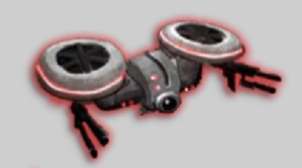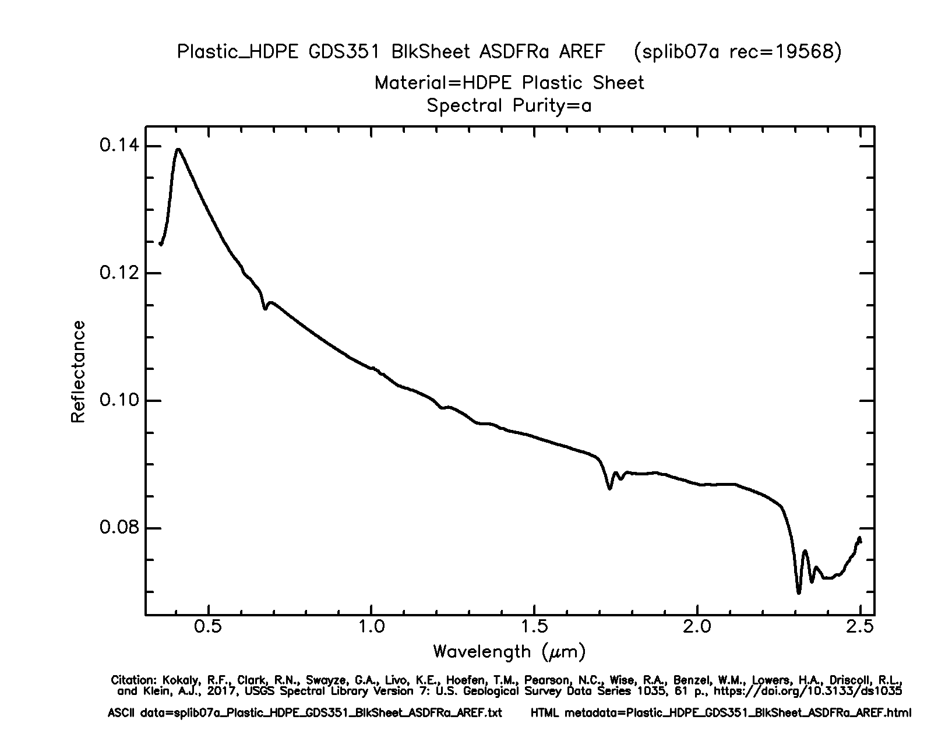

Figure 20: Striker unit and associated reflectance plot from spectral library

Controllers have average health and are not as quick as strikers. A heavier, but robust material for them would be aluminum. The library only has data on brushed aluminum which is not ideal but can still be used.

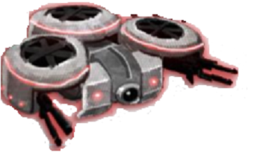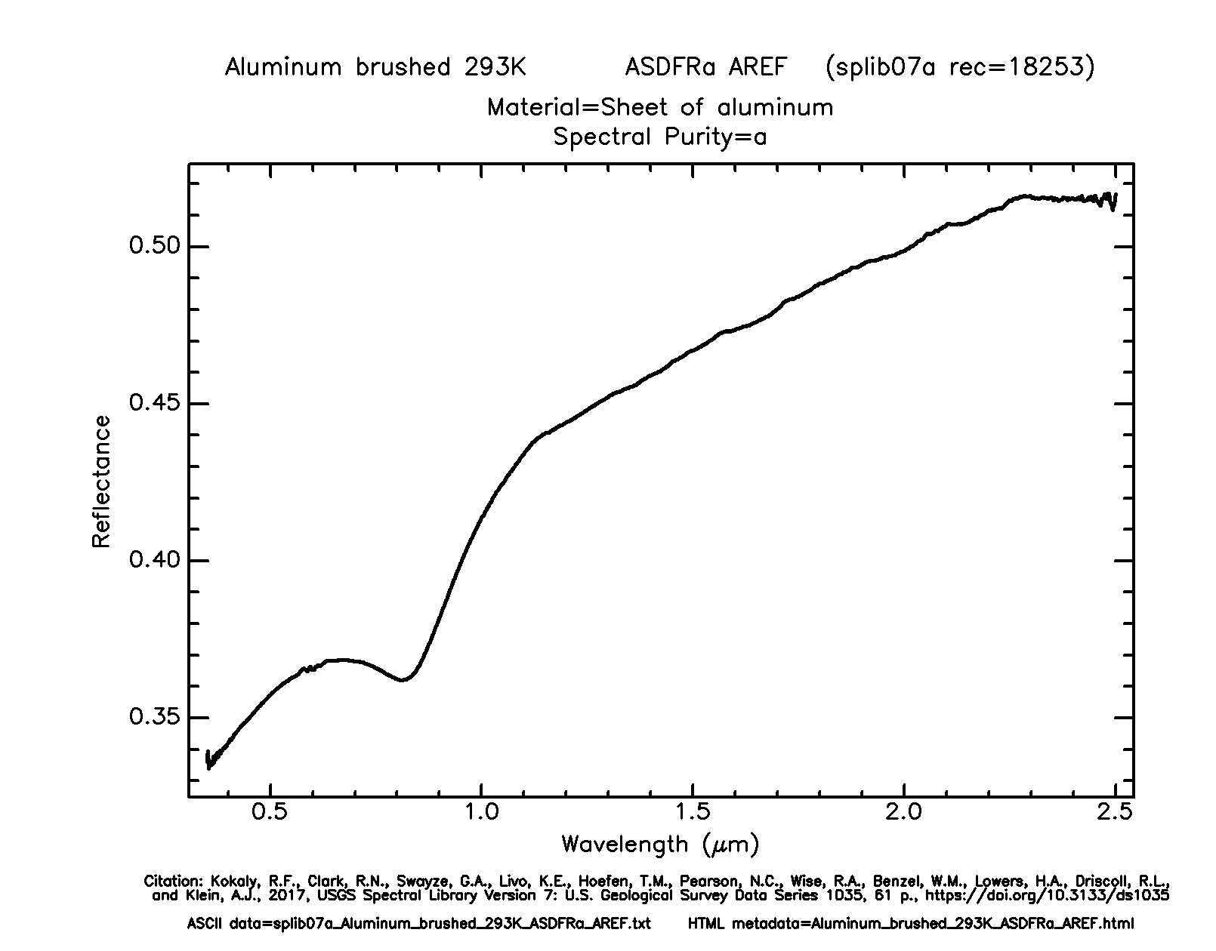

Figure 21: Controller unit and associated reflectance plot from spectral library

The tank has the most health of any unit. Despite moving at the same speed as the controller, it can be assumed that it is made of a stronger material. The spectral library contains galvanized sheet metal from a rain gutter. This is not the ideal material, but it will be assumed that the metal used for the drone would be thicker to provide “armor” to the unit.

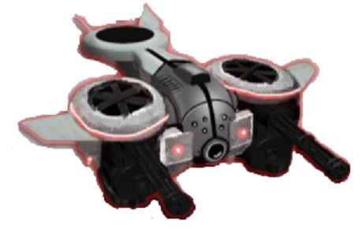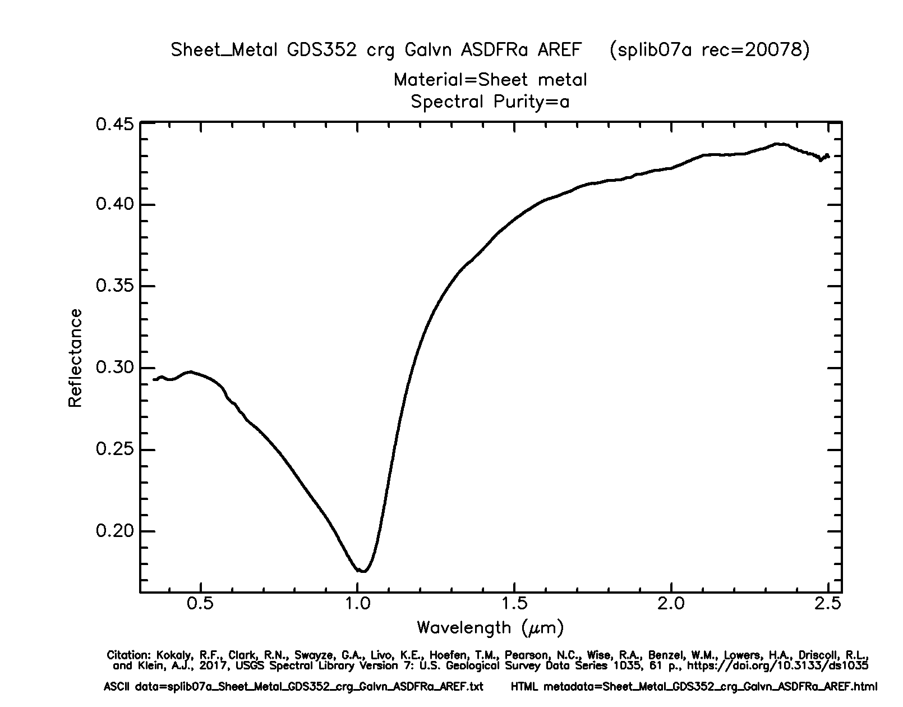

Figure 24: Tank unit and associated reflectance plot from spectral library

Thermal Image

Currently, the user can view a graphical representation of a match, created from post-processed telemetry files in Unreal Engine. These are displayed in the visible spectrum. Displaying the match in a thermal view would be a nice addition to the game, though it would not affect gameplay.

To create a thermal effect for a scene, a texture needs to be created. Then, it can be applied to a material in Unreal to create a thermal material. The material can be used by the meshes of objects in the scene.

First, a thermal color gradient needs to be created (see figure 8). This gradient can be created in photo editing software, such as Photoshop. In the interest of cost, it will be created with GNU Image Manipulation Program, which is free. Inside Unreal, it can be applied to individual objects and even the whole scene.



*Figure 11: Thermal gradient*

Specific objects and the scene are differentiated by using a mask. A scene depth and custom depth with slightly different values are used to differentiate specific objects from the rest of the scene. Differentiating objects as “hot” or “cold” can be done by assigning hot objects to the custom depth and cold objects to the scene depth. Figure 10 shows an example of the mask with the hot object in white and the scene in black.

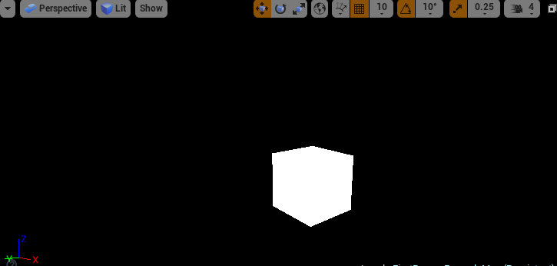

Figure 10: "Hot" cube differentiated from the rest of the scene.

For these hot objects, a Fresnel material is applied to them. Fresnel materials utilize dot product to calculate surface normals. Those facing directly toward the camera have a value of 0, while those perpendicular have a value of 1. This creates a falloff effect (see figure 9).



*Figure 13: Fresnel material in Unreal Engine*

Once this is finished, hot colors from the color gradient can be applied to objects that are using the custom depth and Fresnel material. Cool colors can be applied the remaining scene. A rough example can be seen in Figure 12, but fine tuning will be needed to improve the effect.

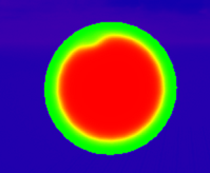

*Figure 14: Thermal effect*

This rough example differentiates between hot and cold. However, as development of this thermal vision progresses, it would be more realistic to use the thermal data described in the section above to choose specific color bands from the color gradient texture. This would create more unique thermal appearances for the different objects in Everglades.

Cost/Benefit of Reacting to Data

With the new unit able to gather data on the positions of other units and bases, a decision needed to be reached for how this unit would react to this information. This reaction could occur either during the game as part of the unit’s game logic or could be presented to the AI agents for them to decide. A cost/benefit analysis was necessary to reach a decision on implementation.

The first option would involve having the recon unit react during the game itself, with the logic occurring inside of the game. This could allow more interesting obstacles for the AI agents, depending on how the game or units reacted to the information. Perhaps the recon unit would retreat or maybe it would alter unit movements based on its knowledge of enemy units. As interesting as this could become, it is not very realistic because the recon unit should not be commanding the other units. Additionally, implementing an idea like this could require large changes to the existing game and there simply isn’t enough time to complete it.

The second option would merely collect the data and make it available to the AI agent that collected it. The decision on any course of action would occur within the AI logic. This solution makes much more sense because the recon unit merely collects data and has no knowledge of where other friendly units are located or any other strategic information. That is the job of the AI agent. So, it would be interesting to see how a user programs an agent to use the data that the recon units collect.

Unit Behaviors

Due to the post-processed graphics, methods must be used in the current version of the project so the recon unit can participate in the game. However, future functionality must be considered. As gameplay extends beyond the scope of this project, it will be played in real-time, meaning the recon unit will have access to an object’s mesh, resulting in different behaviors and methods for gathering data.

Current Unit Functionality

These behaviors allow the recon unit to be unique and participate in the game without the use of graphical data. A couple of ideas were discussed as possibilities.

The first involved a vision bonus to the unit, and thus to the agent, regarding activity in neighboring nodes. This would be like the bonus that a node with watchtower receives, but with the advantage of being mobile. This idea was not pursued because it too closely matches the watchtower’s bonus which removes the advantage of occupying a node with watchtower.

A second idea, with a more specialized advantage, was envisioned and will be implemented. Currently, all combat activity occurs between units located at nodes. In fact, nearly all game functionality occurs at nodes, with the distances between them merely providing delays to combat and capture. It would be extremely useful for agents travelling from one node to another to detect the presence of enemy units that are also moving between units. **Discuss options for behaviors**

Future Unit Functionality

The functionality of the infrared sensor will be implemented, though it will not be operational given the current construction. These functions will be actively used in future game versions, when the graphics are processed in real-time.

Passive Infrared Sensing

Early in the project development cycle, it will be necessary to test whether a recon unit can sense the thermal properties of an object. This can be accomplished in Unreal Engine by using either *line trace* or *shape trace*.

Line trace draws a single line from a specified start point to a specified end point. It returns true if an object was hit during the trace. It also populates an *FHitResult* object with information about the first object hit. This can be useful for finding the name of the object (see figure 11) but can also be used to find that object’s thermal property.



Figure 15: Line trace showing the name and distance of first hit object.

The line trace can also be used to find the distance of the object from the start point, since distance is one of the properties of the *FHitResult* object. This will be useful for determining distances to bases or enemies.

Shape trace is like line trace but operates in a field that matches a certain shape, such as spheres, capsules, and boxes (see figure 12).



*Figure 16: Shape trace showing names of the three cubes it hit.*

This can be used to check a larger field for collisions, such as the field-of-view. The shape’s size can be adjusted, so it can be set to be in proportion to the FOV. The start and end values can be set like a line trace, elongating the shape and providing a range to the sensor.

A single object detected by shape trace would not be very useful. Instead, a shape trace can be used to detect multiple objects in its field. For example, Unreal offers MultiSphereTraceByChannel to use a sphere and find all the objects it hits. Line tracing also has this functionality, but it would not be as realistic considering the infrared should be unable to detect objects behind each other.

Complex Infrared Sensing

The drone units in the game will have their own heat value but they are constantly moving. It would make sense that they would leave a small trail of heat behind them as they fly around. There are a few ways this may be implemented, such as using a ribbon or creating an invisible polygon attached to each drone (see figure 13).



*Figure 17: Creating trails using ribbons in Unreal*

Recon Class UML Diagram

Testing

Unit, Integration, and Functional Testing

For any software application, testing is important step of development that makes sure that parts of a product are working as intended on their own and with other modules. In developing the Everglades game environment, two types of testing will be performed: unit and integration testing.

**Unit Testing**

Unit testing involves testing individual modules of an application in an isolated environment. This means that the module is run without any interactions with dependencies to confirm that the code is executing correctly, and that the logic is sound. Unit tests are overall easier to write and quicker to execute.

**Integration Testing**

Integration testing involves checking if different modules are working together correctly. This type of testing is usually done after sufficient unit tests on each individual module have been performed.

**Functional Testing**

Functional testing is a black box testing technique where the functionality of the application is tested to generate the desired output when providing a certain input. Functional testing is the most time-consuming and most infrequent type of software testing.



The above Figure outlines the general frequency and cost of each type of testing. As shown in the diagram, unit tests are the most frequent type of test case and the least expensive, integration testing follows by having fewer total tests and costing more to run, and functional testing costing the most and having the least amount of test cases.

Testing Strategy

A **big bang** integration testing approach will be implemented for developing the game portion of the Everglades project. In a big bang approach, all modules or units are integrated and tested as a whole at once. The major advantage of using this kind of testing is that everything integrated is tested at one time.



The three main modules for unit testing will adhere to the main objectives of the project. In other words, the modules will be procedural board generation, stochastic wind seeding, and new unit generation. Each of these modules will first be tested individually through unit testing to make sure that their logic is sound. Then the tested units will be implemented into the game server to make sure that they’re working in conjunction with the other units. The reason that a big bang integration testing method is going to be used on this project, is because there are only three members in the group. This means that it should be easier to test all the units at once, since there are less units to test when compared to a group of five or more.

Pytest

Pytest is an important library that can used to create different types of tests ranging from simple tests and complex functional tests. Pytest's documentation shows a simple example of how to create a test case and the result of a failed test case:





A basic test is constructed using the “assert” keyword and created creating some statement to be tested. In this case, assert is used to test if inc(3) will return 5. Since this is not the case, it returns an AssertionError. While this test is relatively simple, testpy allows the ability to group similar test cases into a single class like the example below:



Since pytest discovers all tests following its Conventions for Python test discovery, it finds both “test_” pre-fixed functions. This means that the module can be run just by passing its filename.



The implications of this for testing Everglades are significant, because with pytest, tests for different units can be group into files and easily run by just running the file. In summation pytest files will created for each module for unit testing, and pytest files will also be created for integration testing.

Possible Unit Tests

Stochastic Wind Generation

* Making sure that seeds produce consistent values when returned
* Confirming that each node in a list
* Testing to make sure that a wind value is correctly being added to the telemetry data
* Making sure that wind modifier is correctly effecting unit movement speed
* Testing to make sure generated numbers are correctly being transformed into percentage modifier

Procedural Game Board Generation

* Ensuring only valid maps are generated
* Testing game initialization to make sure the generated map is loaded correctly into the main application procedure
* Checking telemetry data to see if all nodes of the random map are being processed correctly
* Ensuring the generated map is included in the final telemetry data output

New Unit